INDEX

Table Of Contents | Page No.
1. Abstract
- Introduction
  - Motivation
  - Problem Statement
  - Purpose/Objectives and Goals
  - Project Scope and Limitations

- System Analysis
  - Existing system
  - Scope and limitation of existing system
  - Project perspective, features
  - Stakeholders
  - Requirement analysis–Functional requirements, performance Requirement, security requirements etc.
- System design
  - Design constraints
  - System model: ERD & DFD (Context Level)
  - Data Model
  - User interfaces- Input Output Screens
5. Implementation Details
Software/Hardware specification
- Outputs and Report Testing
  - Test plan
  - Black box testing and data validation test cases
  - White box testing or functional validation test cases and results
7. Conclusion and Recommendation
8. Future Scope
9. Bibliography and references

1.ABSTRACT

Healthcare appointment scheduling is often handled manually through phone calls or in-person visits, leading to long waiting times, scheduling conflicts, and poor communication between patients, doctors, and hospital staff. Health Prime is a web-based hospital appointment booking system designed to address these problems by digitizing the entire appointment lifecycle — from patient registration to doctor consultation.
The system supports three distinct user roles: patients, who can register, browse doctors across four specialties (Cardiology, Gynecology, ENT, and Orthopedics), book appointments by filling specialty-specific medical forms, and track their appointment status through a dynamically updating digital receipt; doctors, who manage their own patient queue through a dedicated dashboard, confirming or declining pending requests and updating visit outcomes; and administrators, who oversee the platform, manage doctor accounts, and act as the final authority on cancellation or rescheduling requests raised by doctors, ensuring accountability is maintained for every status change.
The system is built using PHP and MySQL for server-side logic and data storage, with HTML, CSS, and JavaScript for the front end, and is deployed locally using XAMPP. Key features include role-based authentication, automated email notifications via PHPMailer, a token-based queuing system, CSRF-protected forms, and a structured approval workflow for appointment modifications that keeps patients informed with clear, reason-backed updates.
By automating appointment scheduling and introducing clear role separation and accountability, Health Prime reduces administrative overhead, minimizes scheduling errors, and improves the overall patient experience.

2. INTRODUCTION

Hospitals and clinics traditionally rely on manual processes — phone calls, walk-in registers, and paper-based token systems — to manage patient appointments. As patient volume grows, this approach becomes increasingly difficult to manage, often resulting in long queues, double bookings, miscommunication between staff and patients, and no clear record of who approved or changed what. Health Prime is proposed as a digital solution to this problem, bringing patients, doctors, and administrative staff onto a single, structured platform.

2.1 MOTIVATION

Most small to mid-sized clinics still depend on informal booking methods that do not scale well and offer little transparency to the patient. A patient calling to book an appointment has no way to track its status, and a doctor wanting to reschedule a patient has to coordinate this manually through front-desk staff, with no record of why the change was made. This project was motivated by the need to bring structure, accountability, and transparency to this process — letting each participant (patient, doctor, admin) interact with a system that clearly defines what they can see and do, while keeping a clear trail of who requested or approved each change.

2.2 PROBLEM STATEMENT

Manual appointment systems suffer from several recurring issues:
- Patients have no way to independently verify or track the status of their appointment.
- There is no structured way for a doctor to request a change (such as a cancellation or reschedule) without going through informal, undocumented channels.
- Administrative staff often have either too much control (making arbitrary changes without doctor input) or too little visibility (no central view of all appointments across departments).
- There is no automated way to notify a patient when their appointment status changes, leading to missed or duplicate visits.
Health Prime addresses these issues by building a role-based system where each action is explicitly permitted, logged with a reason where relevant, and reflected to the patient automatically.

2.3 PURPOSE/OBJECTIVES & GOALS
The primary purpose of Health Prime is to provide a reliable, user-friendly web-based platform that simplifies doctor appointment booking for patients and streamlines appointment management for healthcare providers.
The primary Objectives & Goals of this project are to:
- Provide patients with a simple interface to register, log in, and book appointments across multiple medical specialties.
- Allow each doctor to manage only their own patients, with the ability to confirm, decline, or update the outcome of an appointment.
- Ensure that once an appointment is confirmed, it cannot be unilaterally cancelled or changed by either party without a documented reason — doctors must request such changes, and admin must either approve or deny them with a stated reason.
- Keep patients informed automatically, through both a live-updating digital receipt and email notifications, whenever their appointment status changes.
- Give administrative staff full visibility into all appointments, patients, and doctor accounts, without granting them the ability to override doctor-led medical decisions arbitrarily.
- Apply standard web security practices — hashed passwords, prepared SQL statements, CSRF protection, and role-separated sessions — throughout the system.

2.4 PROJECT SCOPE AND LIMITATIONS
Scope:
The system covers four medical specialties (Cardiology, Gynecology, ENT, and Orthopedics), patient registration and login, specialty-specific medical intake forms, a token-based queue per doctor, a three-role access model (patient, doctor, admin), a cancellation/reschedule request-and-approval workflow, automated email notifications, and a contact/feedback inbox for admin.
Limitations:
- The system is built and tested for local deployment (XAMPP) and has not been deployed to a live production server.
- Doctor "availability" status is currently a visibility indicator for admin and the doctor only — it does not yet prevent new patients from booking that doctor, since the specialty listing pages are static HTML and not yet connected to the database.
- Token numbers are currently generated on the client side at booking time rather than validated against existing bookings on the server, which could theoretically allow two patients to be assigned the same token for the same slot.
- The system does not include online payment processing.
- It is designed for a single hospital/clinic; it is not a multi-tenant system supporting multiple hospitals.

3. SYSTEM ANALYSIS

System analysis is the process of studying a system or its parts in order to identify its goals and purposes, and to discover operations and procedures for accomplishing them more efficiently. For Health Prime, system analysis involves understanding the existing appointment booking methods used in hospitals and clinics, identifying their shortcomings, and defining the requirements for a better, automated solution.

3.1 Existing System
In most small and mid-sized clinics, appointment booking is handled manually. A patient typically calls the reception desk or visits in person to request an appointment with a specific doctor. The receptionist checks a physical register or a simple spreadsheet to find an open slot, assigns a token number by hand, and informs the patient verbally or via a phone call. Any changes — a doctor becoming unavailable, an appointment needing to be rescheduled, or a patient wanting to cancel — are communicated informally, usually over the phone, with no permanent record of who requested the change or why.

3.2 Scope and Limitations of Existing System
The existing manual system has several shortcomings:
- No independent status tracking: A patient cannot check their appointment status without calling the clinic directly.
- No audit trail: If a doctor asks for a reschedule, there is no record of the reason, who approved it, or when it happened.
- Token conflicts: Token numbers assigned by hand are prone to human error, including duplicate tokens for the same slot.
- No centralized visibility: Administrative staff have no single view of appointments across departments; records are often scattered across registers or spreadsheets per department.
- No automated notifications: Patients are not proactively informed of changes and may show up for a cancelled or rescheduled appointment.
- Inconsistent authority: Without clear role boundaries, both front-desk staff and doctors may make conflicting changes to the same appointment.
3.3 Project Perspective and Features
Health Prime is designed as a replacement for this manual process — a self-contained web application rather than an extension of an existing system. It introduces clear role boundaries and a documented approval process for any change made after an appointment is confirmed.
Key features include:
- Patient registration and secure login.
- Browsing doctors across four specialties, each with a dedicated medical intake form.
- A token-based queue system per doctor, per date and slot.
- A live-updating digital receipt showing the current appointment status (Pending, Confirmed, Completed, Cancelled, or No-show), viewable, printable, and downloadable at any time.
- A doctor dashboard restricted to that doctor's own patients only, supporting Confirm/Decline on new requests and Completed/No-show on confirmed ones.
- A structured request-and-approval workflow: once confirmed, a doctor cannot cancel or reschedule an appointment directly — they submit a request with a reason, which admin must either approve (applying the change and notifying the patient) or deny (with a reason the doctor can see).
- An admin panel with dashboard statistics, full appointment visibility, patient records, doctor account management, and a contact-message inbox.
- Automated email notifications sent to patients when their appointment is confirmed, cancelled, or rescheduled.
- A doctor-controlled availability toggle.

3.4 Stakeholders
The following stakeholders are involved in or affected by the Health Prime system:
Stakeholder | Role in the System
Patients | Registers, books appointments, tracks status, receives email updates, and can view a full history of past and upcoming bookings.
Doctors | Manages their own confirmed patients, marks visits complete or no-show, requests cancellations/reschedules, and sets their own availability.
Administrators | Oversees the whole system: manages doctor accounts, approves or denies doctor requests, and handles contact-form enquiries.
Hospital/Clinic management  (indirect stakeholder) | Gains a structured, auditable record of appointments in place of a manual register.

3.5 Requirement Analysis
Requirement analysis identifies what the system must do (functional requirements), how well it must perform (performance requirements), and how it must protect data (security requirements).
Functional Requirements:
- Users must be able to register and log in with a hashed, securely stored password.
- Patients must be able to book an appointment by selecting a specialty, a doctor, a date, a slot, and submitting a medical intake form.
- The system must generate and display a token number for each booking.
- Patients must be able to view the real-time status of any of their appointments.
- Doctors must be able to view only appointments assigned to them, and update status within allowed transitions (e.g., Pending → Confirmed/Cancelled; Confirmed → Completed/No-show).
- Doctors must be able to submit a cancellation or reschedule request, with a reason, for a confirmed appointment.
- Admin must be able to approve or deny a doctor's request, with a reason recorded either way.
- The system must send an email notification to the patient when their appointment is confirmed, cancelled, or rescheduled.
- Admin must be able to view all appointments, patients, doctor accounts, and contact messages.
Performance Requirements:
- Pages should load and respond to user actions without noticeable delay under typical local/clinic-scale usage (a handful of concurrent users).
- Status updates (e.g., a doctor confirming an appointment) must be reflected immediately when the patient refreshes their receipt — no manual syncing or delay.
Security Requirements:
- Passwords must be hashed (never stored in plain text).
- All database queries must use prepared statements to prevent SQL injection.
- All state-changing form submissions must be protected against Cross-Site Request Forgery (CSRF) using per-session tokens.
- Each role (patient, doctor, admin) must have an isolated session, so a login in one role cannot be used to access another role's pages.
- A doctor must not be able to view or modify another doctor's patient records.
- Admin must not be able to cancel or reschedule a confirmed appointment without an existing request from the doctor — this must be enforced at the database query level, not just hidden in the interface.
- All user-supplied output displayed back to the browser must be escaped to prevent Cross-Site Scripting (XSS).
- Redirect destinations (e.g., after login) must be validated against a fixed allow-list to prevent open-redirect vulnerabilities.
Reliability Requirement:
- A failure in the email-sending service (e.g., no internet connection) must not prevent the underlying status change from being saved — the appointment update should always succeed independently of whether the notification email succeeds.

4. SYSTEM DESIGN

System design is the process of defining the architecture, modules, components, interfaces, and data flow of a system in order to satisfy its specified requirements. It serves as the blueprint for the development phase, translating the requirements identified during system analysis into a concrete plan for how the system will be built and how its components will function together.
For Health Prime, system design covers both the structural and visual aspects of the application. This includes how the data is organized and stored in the database, how the different pages and PHP modules interact with each other, how user authentication and session management are handled, and how the user interface is presented to the patient at every stage of the appointment booking process.
The design of Health Prime follows a layered approach — separating the presentation layer (HTML, CSS, JavaScript), the logic layer (PHP), and the data layer (MySQL). Each layer has a clearly defined responsibility, making the system organized, maintainable, and easy to understand. Together, these layers form a cohesive web application that delivers a smooth and secure experience from registration to appointment confirmation.

4.1 DESIGN CONSTRAINS
Design constraints are the limitations and conditions that influenced the design decisions made during the development of Health Prime.
- The system must run on the XAMPP stack (Apache, MySQL/MariaDB, PHP) without requiring Composer or any package manager, since the development environment does not have reliable outbound internet access for dependency installation — third-party libraries (such as PHPMailer) are bundled directly into the project folder.
- Each appointment specialty (Cardiology, Gynecology, ENT, Orthopedic) uses its own dedicated table rather than a single shared table, since each specialty collects a different set of medical fields. This avoids a sparse, mostly-null shared schema at the cost of some query duplication.
- A doctor's identity in the appointment tables is stored as a plain text name (doctor_name), not a foreign key to the doctors table, because the original booking pages pass the doctor's name directly from static HTML. Admin must select a doctor's name from a fixed dropdown (rather than typing it) when creating a doctor login, to guarantee this text match stays exact.
- All session-based roles (patient, doctor, admin) must use separate PHP session names, so that logging in as one role does not grant access to another role's pages.

4.2 SYSTEM MODEL: ERD & DFD
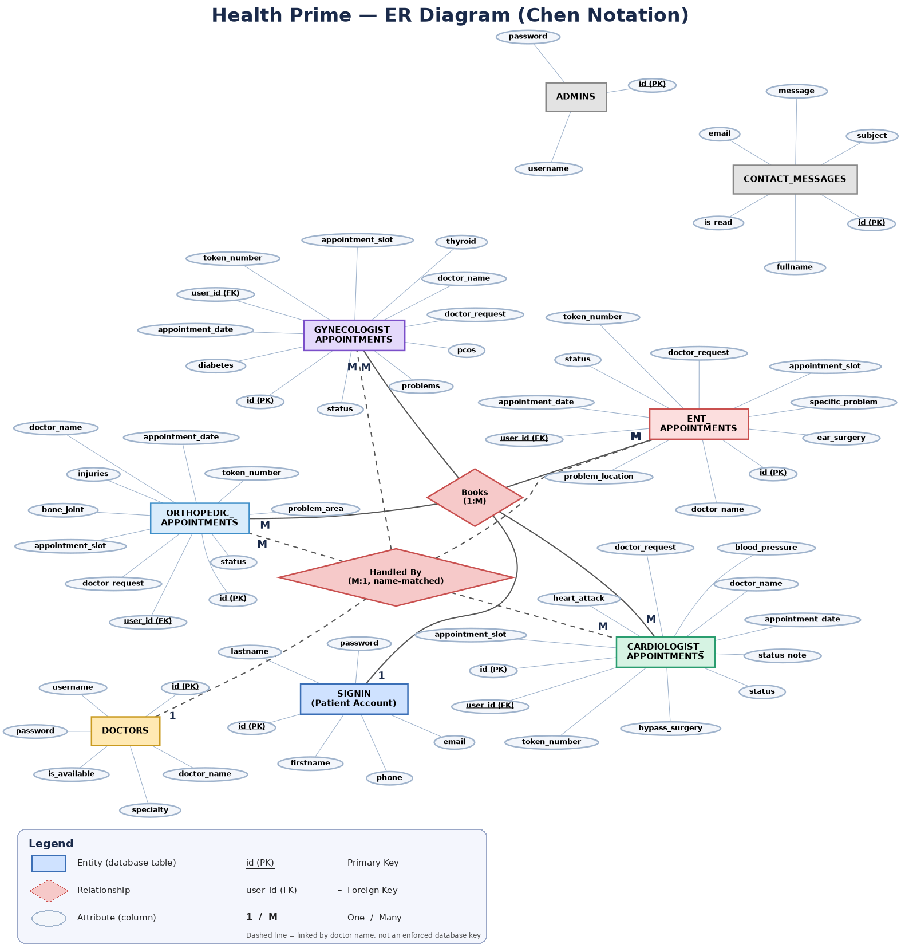
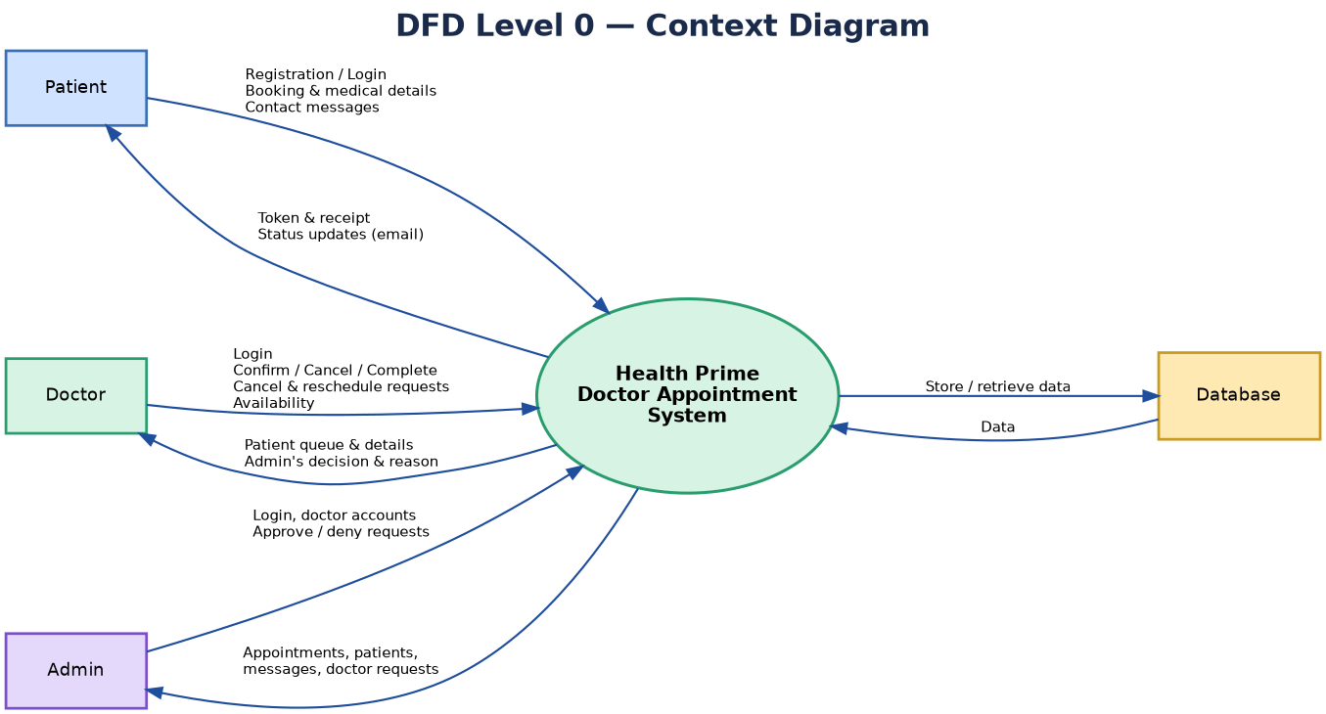
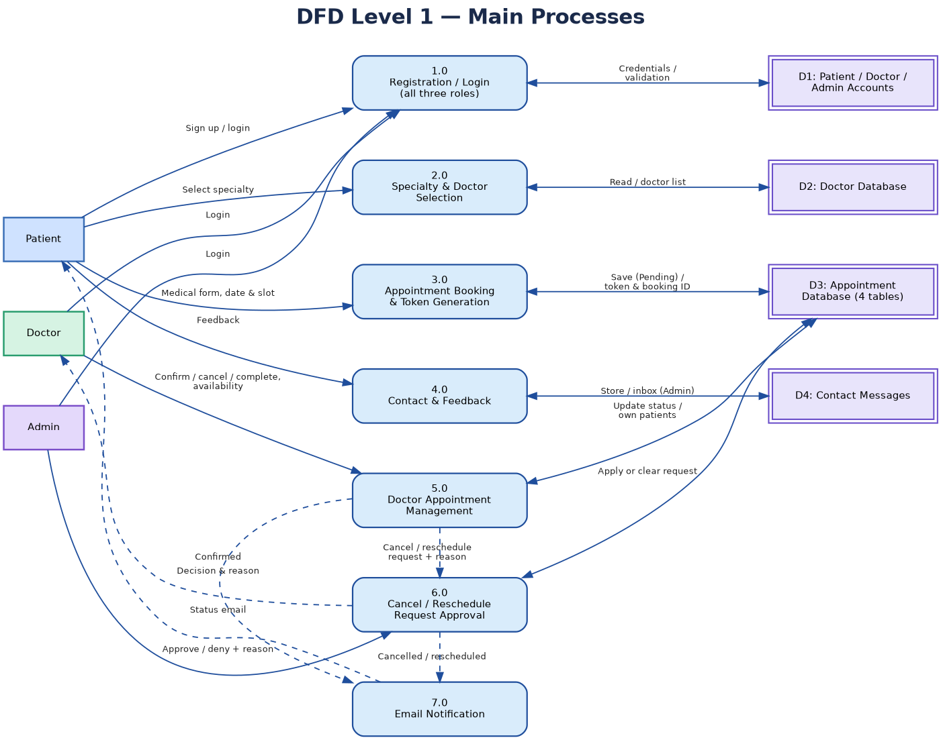

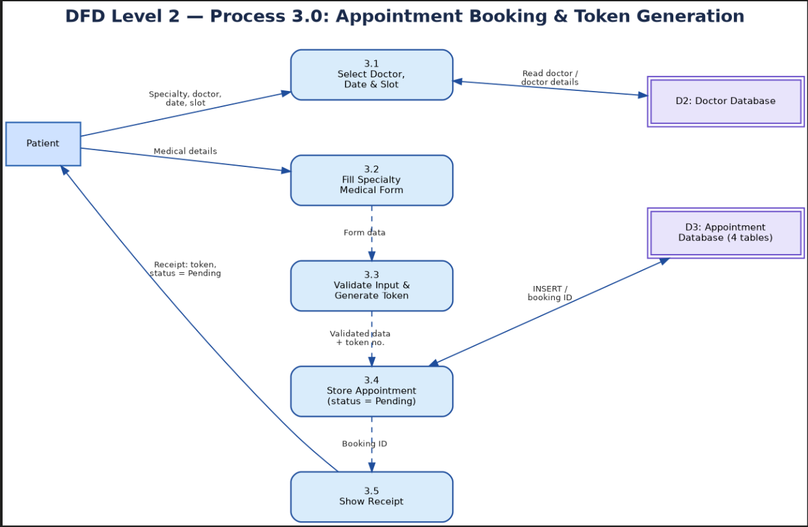

4.3 DATA MODEL
The application uses a single MySQL/MariaDB database, health_prime, made up of the tables summarised below. Every appointment table shares a common set of columns for the patient, the booking itself, and its status/approval workflow; each then adds its own specialty-specific medical-history columns.
Table | Purpose | Key fields
signin | Patient accounts | id (PK), email, password (hashed)
doctors | Doctor login accounts | id (PK), specialty, doctor_name, username, password (hashed), is_available
admins | Admin login accounts | id (PK), username, password (hashed)
cardiologist_appointments | Cardiology bookings | id (PK), user_id (FK → signin), doctor_name, medical fields, status, doctor_request, status_note
gynecologist_appointments | Gynecology bookings | Same structure, with gynecology-specific medical fields
ent_appointments | ENT bookings | Same structure, with ENT-specific medical fields
orthopedic_appointments | Orthopedic bookings | Same structure, with orthopedic-specific medical fields
contact_messages | "Contact us" submissions | id (PK), fullname, email, subject, message, is_read

Table 1: signin
Field | Type | Key | Notes
id | INT | PK | Auto-increment
phone | VARCHAR(15)
firstname | VARCHAR(50)
lastname | VARCHAR(50)
email | VARCHAR(100) |  | Unique in practice
password | VARCHAR(255) |  | Hashed
Table 2: doctors
Field | Type | Key | Notes
id | INT | PK | Auto-increment
specialty | VARCHAR(30) |  | e.g. Cardiologist
doctor_name | VARCHAR(100) |  | Matches the appointment tables' doctor_name text
username | VARCHAR(50) | Unique
password | VARCHAR(255) |  | Hashed
is_available | TINYINT(1) |  | Default 1; doctor-controlled toggle

Table 3: admin
Field | Type | Key | Notes
id | INT | PK | Auto-increment
username | VARCHAR(50) | Unique
password | VARCHAR(255) |  | Hashed

Table 4: cardiologist_appointments
Field | Type | Key | Notes
id | INT | PK | Auto-increment
user_id | INT | FK → signin.id
doctor_name | VARCHAR(100) |  | Text match, not FK
fullname | VARCHAR(100) |  | Patient name
age | INT
height | FLOAT
weight | FLOAT
gender | VARCHAR(10)
mobile | VARCHAR(15)
email | VARCHAR(100)
address | TEXT
current_issue | TEXT
blood_pressure | VARCHAR(30)
heart_attack | VARCHAR(5) |  | Yes/No
heart_attack_count | INT
bypass_surgery | VARCHAR(5) |  | Yes/No
visit_reason | TEXT
bed_rest | VARCHAR(5) |  | Yes/No
appointment_date | DATE
appointment_slot | VARCHAR(50)
token_number | INT
status | ENUM |  | Pending/Confirmed/Cancelled/Completed/No-show
doctor_request | ENUM |  | None/Cancel/Reschedule
doctor_note | TEXT |  | Doctor's reason for request
requested_date | DATE |  | Doctor's proposed new date
requested_slot | VARCHAR(50) |  | Doctor's proposed new slot
status_note | TEXT |  | Admin's patient-facing reason
denial_note | TEXT |  | Admin's reason if request denied

Table 5: gynecologist_appointments
Field | Type | Key | Notes
id | INT | PK | Auto-increment
user_id | INT | FK → signin.id
doctor_name | VARCHAR(100)
fullname | VARCHAR(100)
age | INT
height | FLOAT
weight | FLOAT
gender | VARCHAR(10)
mobile | VARCHAR(15)
email | VARCHAR(100)
address | TEXT
problems | TEXT |  | Selected checkboxes
current_problem | TEXT
pcos | VARCHAR(10)
thyroid | VARCHAR(10)
diabetes | VARCHAR(10)
other_history | TEXT
visit_reason | TEXT
bed_rest | VARCHAR(5)
appointment_date | DATE
appointment_slot | VARCHAR(50)
token_number | INT
status | ENUM |  | Same 5 values as above
doctor_request | ENUM |  | None/Cancel/Reschedule
doctor_note | TEXT
requested_date | DATE
requested_slot | VARCHAR(50)
status_note | TEXT
denial_note | TEXT

Table 6: ent_appointments
Field | Type | Key | Notes
id | INT | PK | Auto-increment
user_id | INT | FK → signin.id
doctor_name | VARCHAR(100)
fullname | VARCHAR(100)
age | INT
height | FLOAT
weight | FLOAT
gender | VARCHAR(10)
mobile | VARCHAR(15)
email | VARCHAR(100)
address | TEXT
problem_location | VARCHAR(50) |  | Ear/Nose/Throat
specific_problem | VARCHAR(100)
ear_surgery | VARCHAR(60)
nose_surgery | VARCHAR(60)
throat_surgery | VARCHAR(60)
visit_reason | TEXT
bed_rest | VARCHAR(5)
appointment_date | DATE
appointment_slot | VARCHAR(50)
token_number | INT
status | ENUM |  | Same 5 values as above
doctor_request | ENUM |  | None/Cancel/Reschedule
doctor_note | TEXT
requested_date | DATE
requested_slot | VARCHAR(50)
status_note | TEXT
denial_note | TEXT

Table 7: orthopedic_appointments
Field | Type | Key | Notes
id | INT | PK | Auto-increment
user_id | INT | FK → signin.id
doctor_name | VARCHAR(100)
fullname | VARCHAR(100)
age | INT
height | FLOAT
weight | FLOAT
gender | VARCHAR(10)
mobile | VARCHAR(15)
email | VARCHAR(100)
address | TEXT
current_problem | TEXT
problem_area | TEXT |  | Selected checkboxes
bone_joint | VARCHAR(50)
bone_joint_other | VARCHAR(50)
injuries | VARCHAR(50)
injuries_other | VARCHAR(50)
surgeries | VARCHAR(50)
surgeries_other | VARCHAR(50)
conditions | VARCHAR(50)
conditions_other | VARCHAR(50)
visit_reason | TEXT
bed_rest | VARCHAR(5)
appointment_date | DATE
appointment_slot | VARCHAR(50)
token_number | INT
status | ENUM |  | Same 5 values as above
doctor_request | ENUM |  | None/Cancel/Reschedule
doctor_note | TEXT
requested_date | DATE
requested_slot | VARCHAR(50)
status_note | TEXT
denial_note | TEXT

Table 8: contact_messages ("Contact Us" submissions)
Field | Type | Key | Notes
id | INT | PK | Auto-increment
fullname | VARCHAR(100)
email | VARCHAR(100)
phone | VARCHAR(20)
subject | VARCHAR(200)
message | TEXT
is_read | TINYINT(1) |  | Default 0

4.4 User interfaces - Input Output Screens

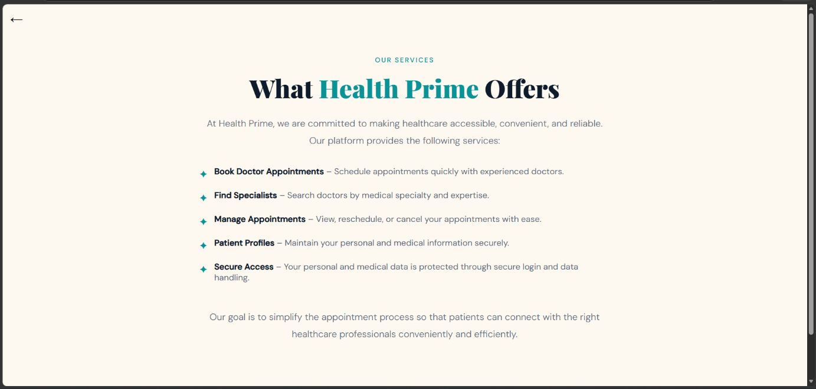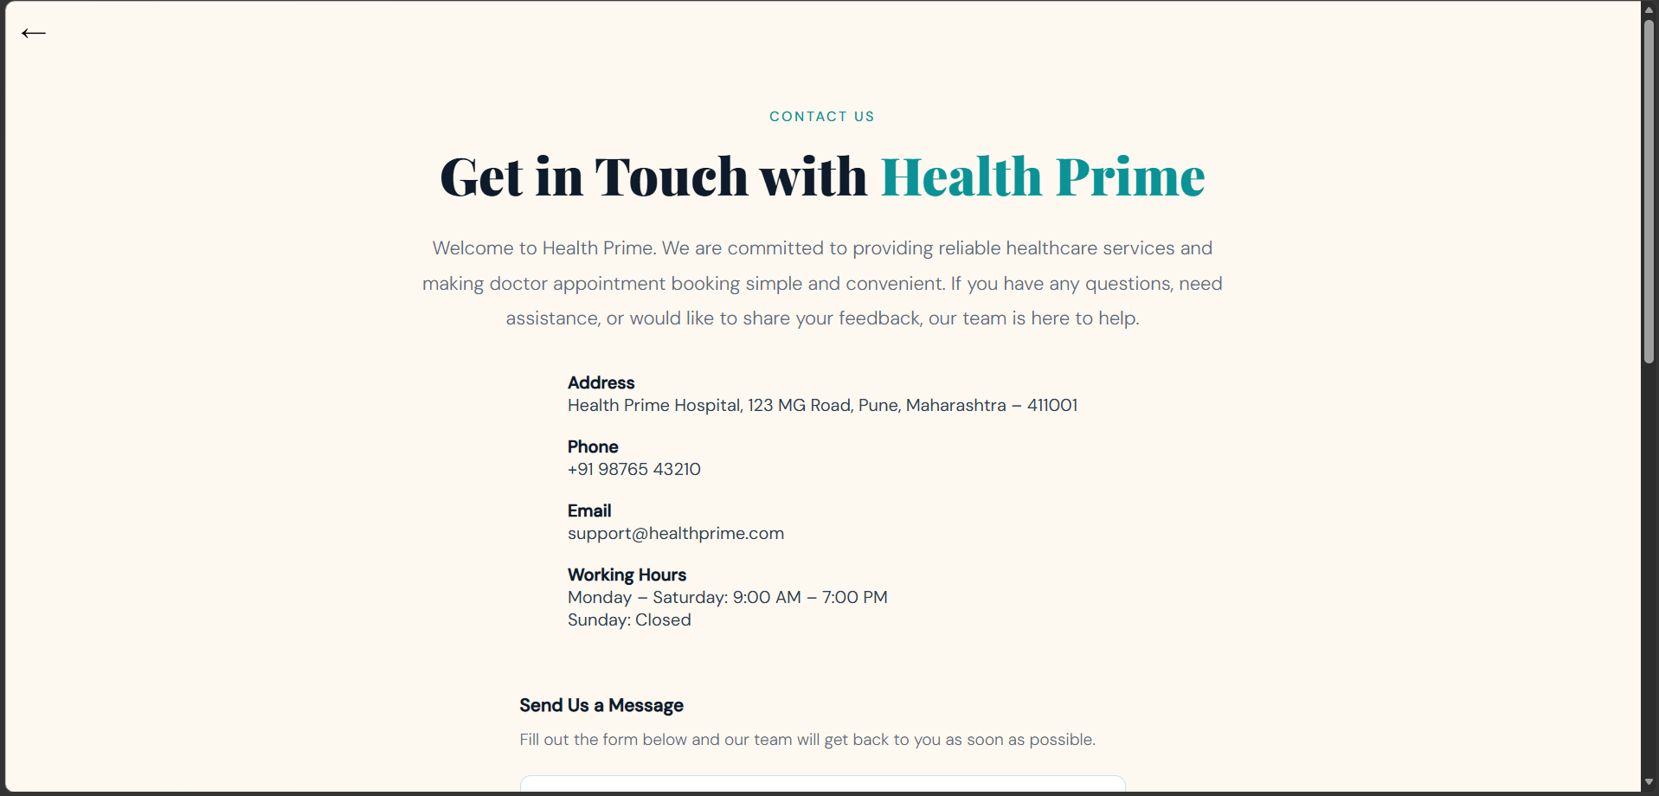
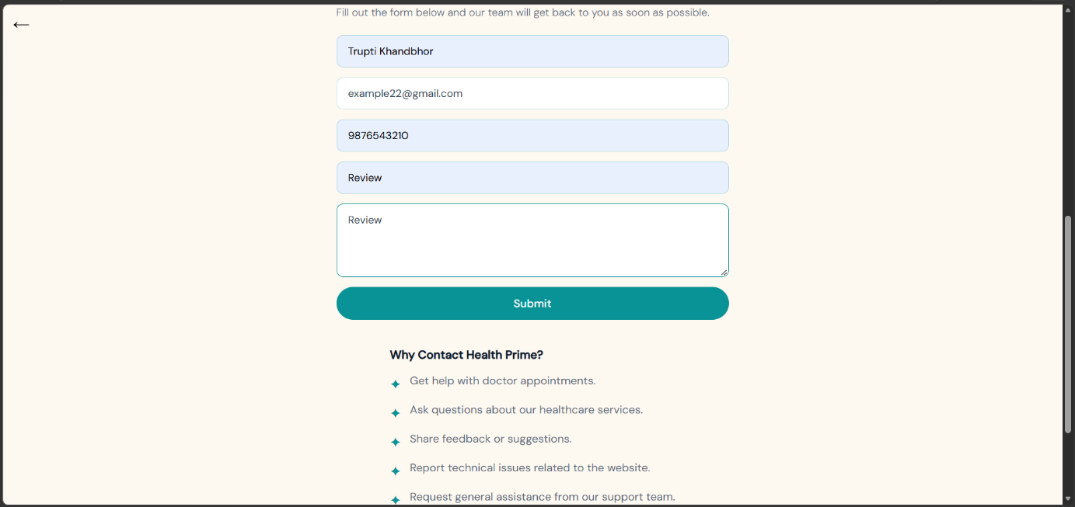
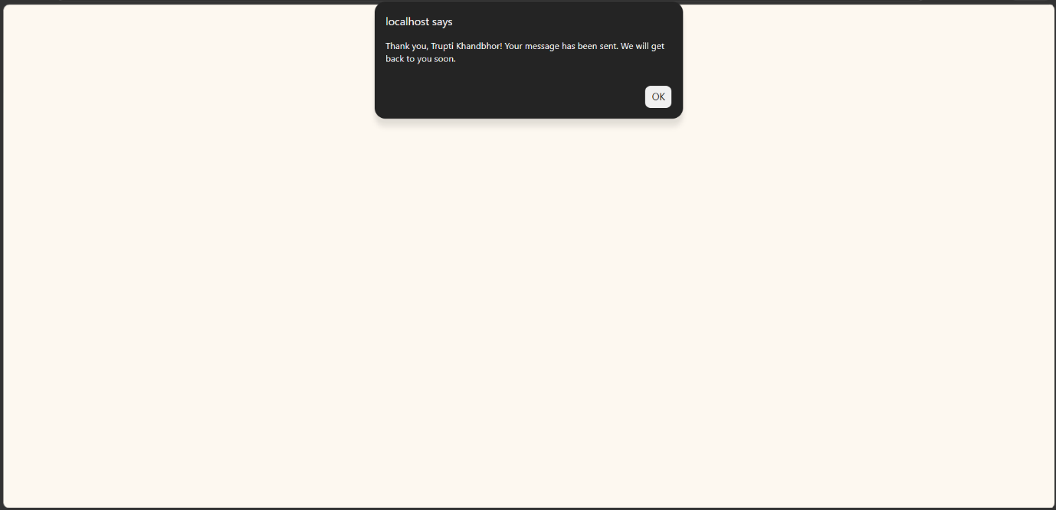
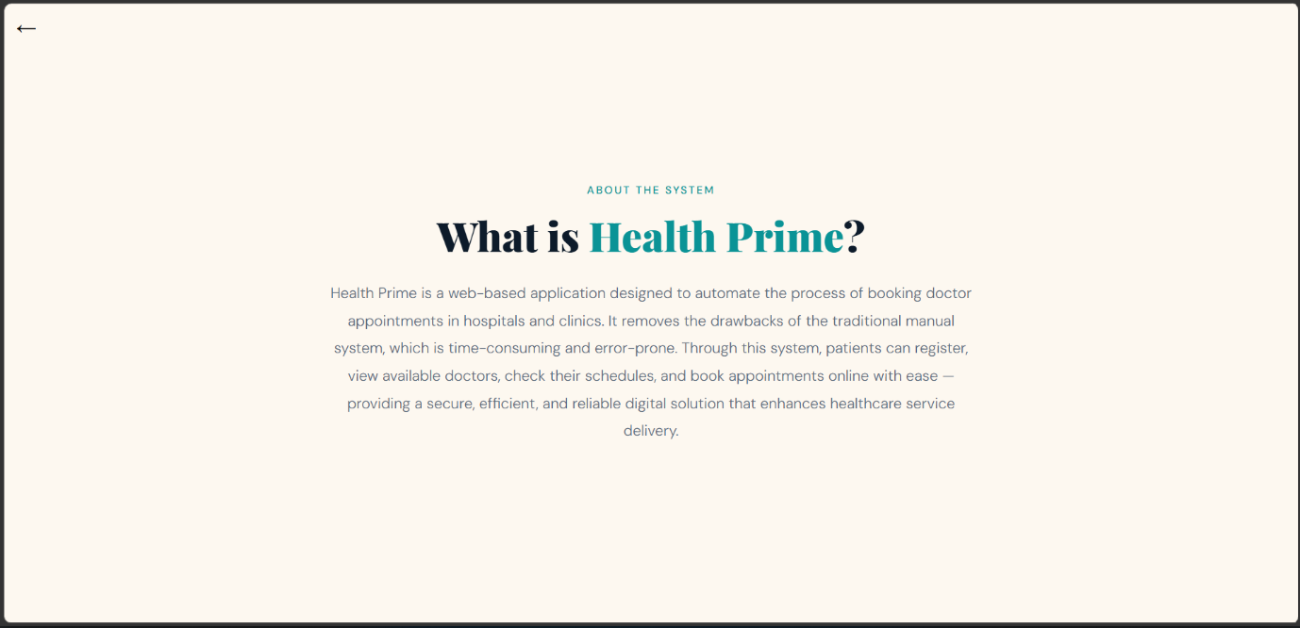
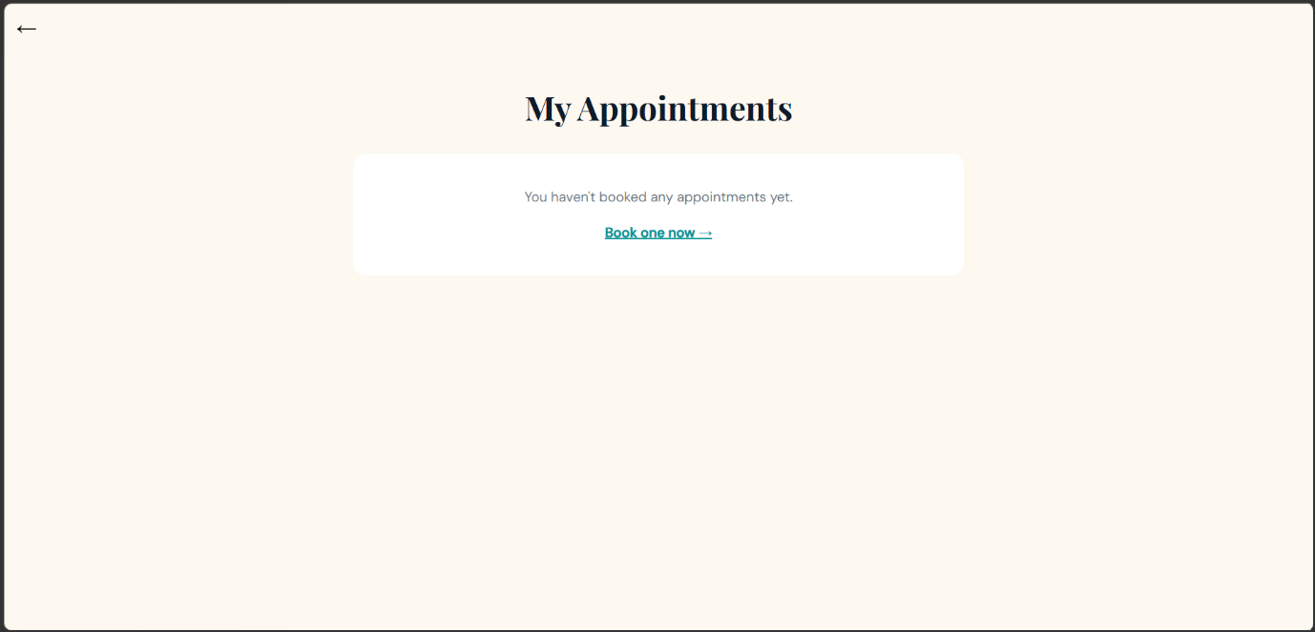
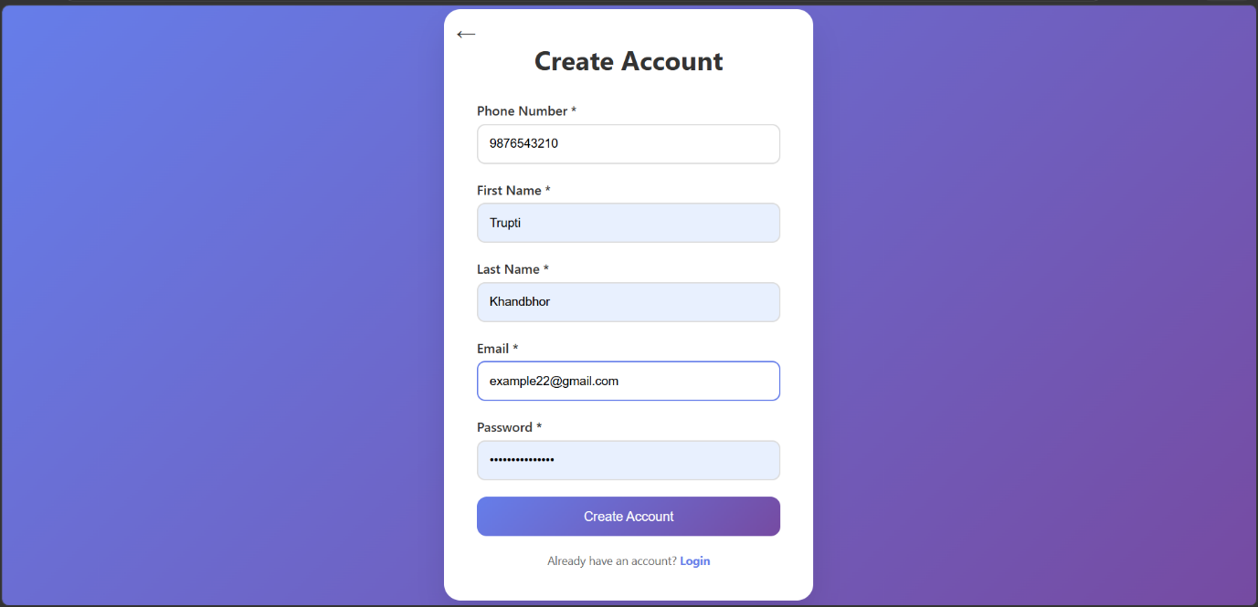
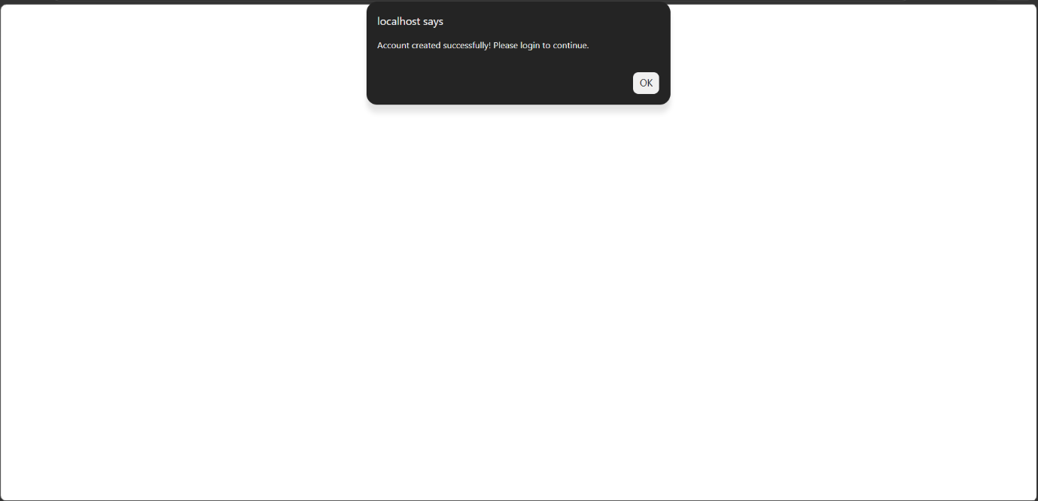
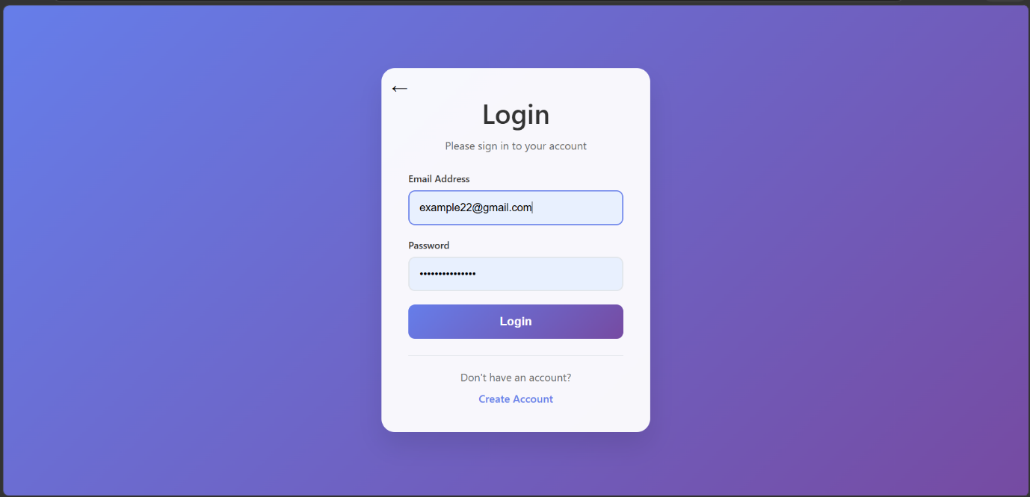
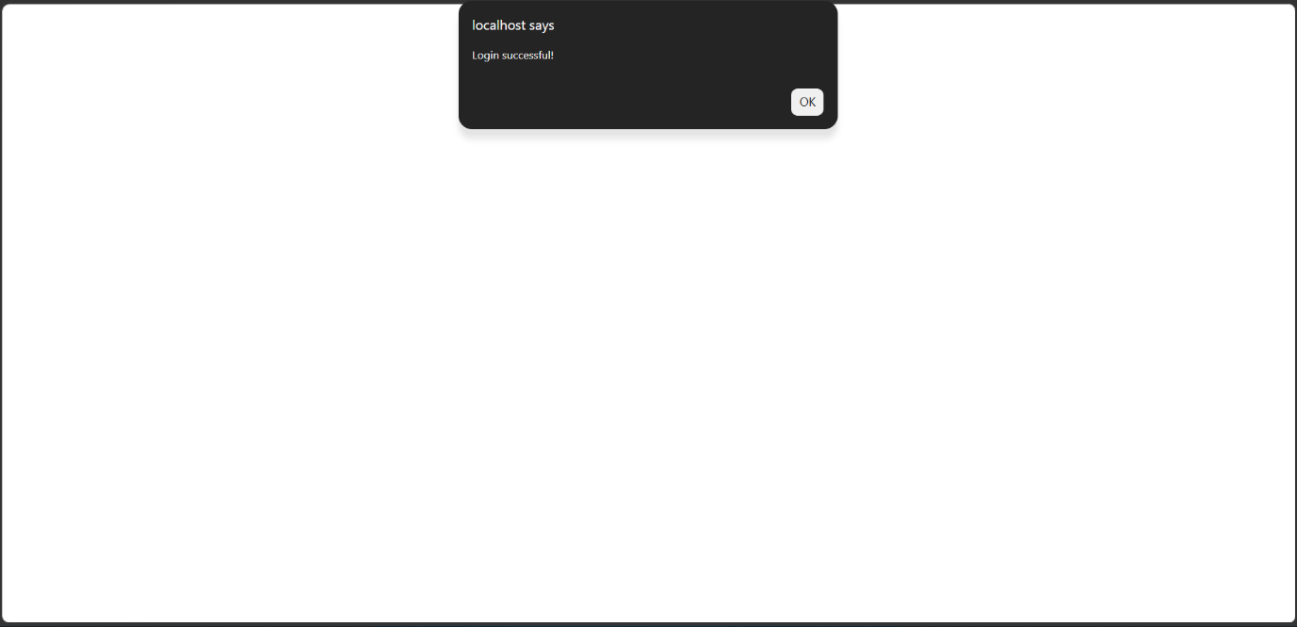
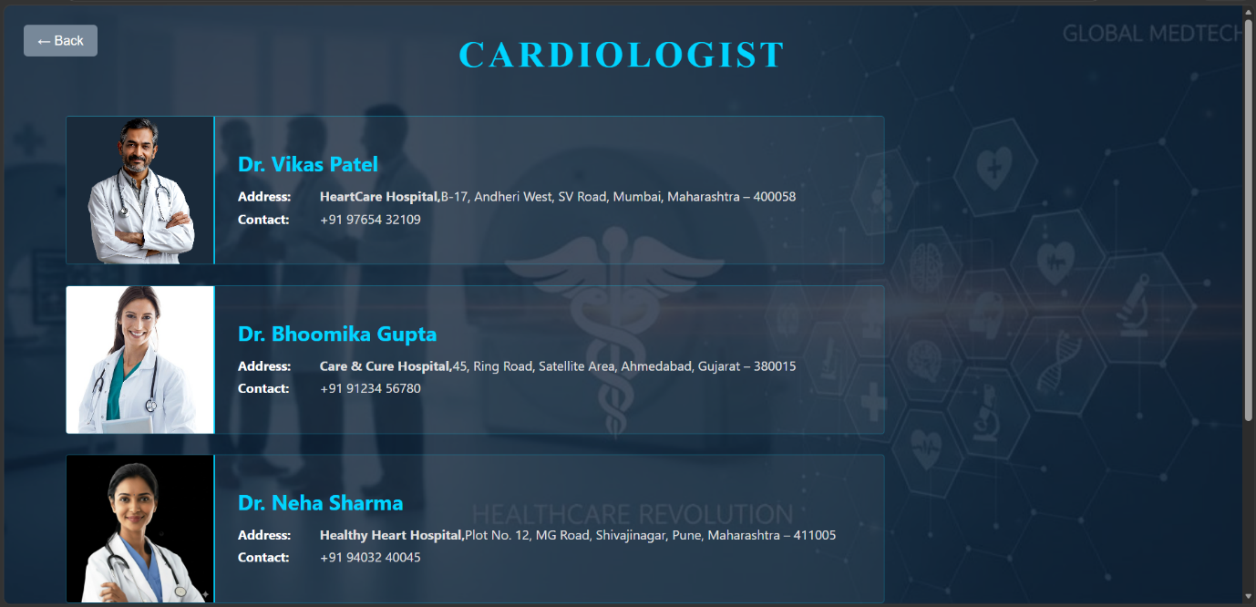
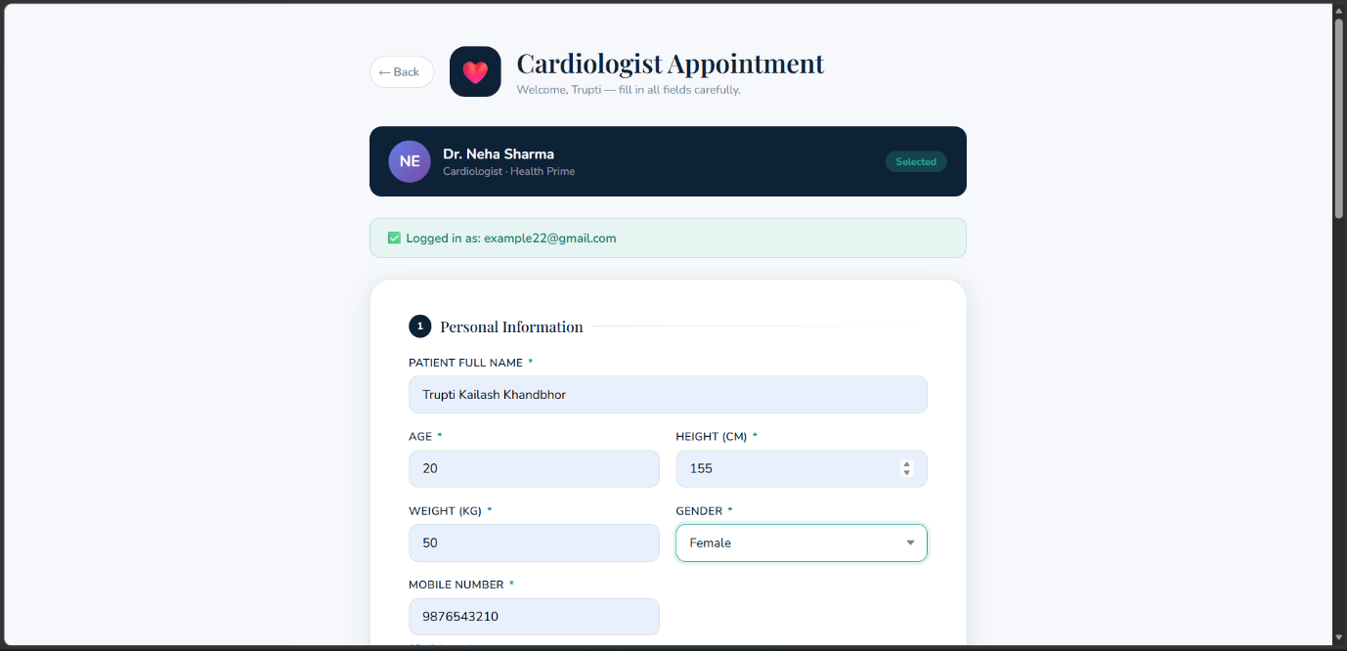
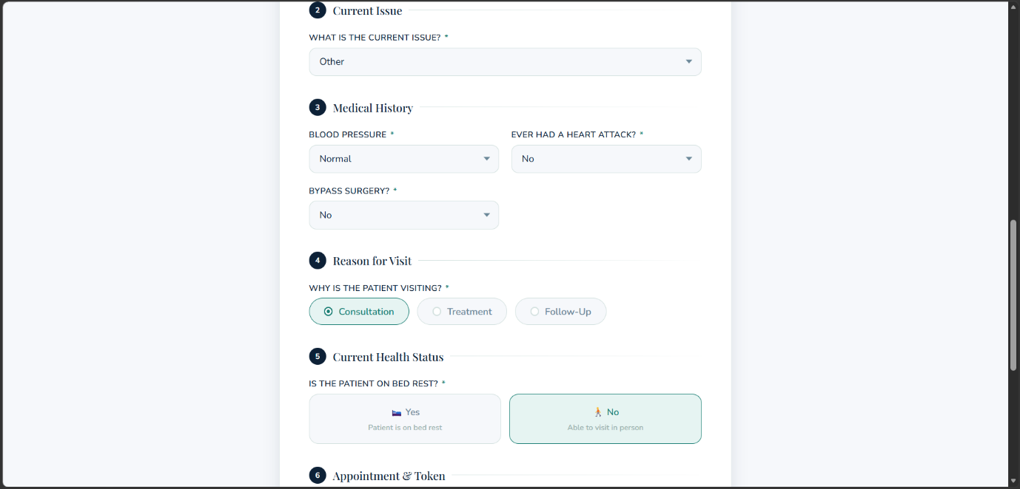
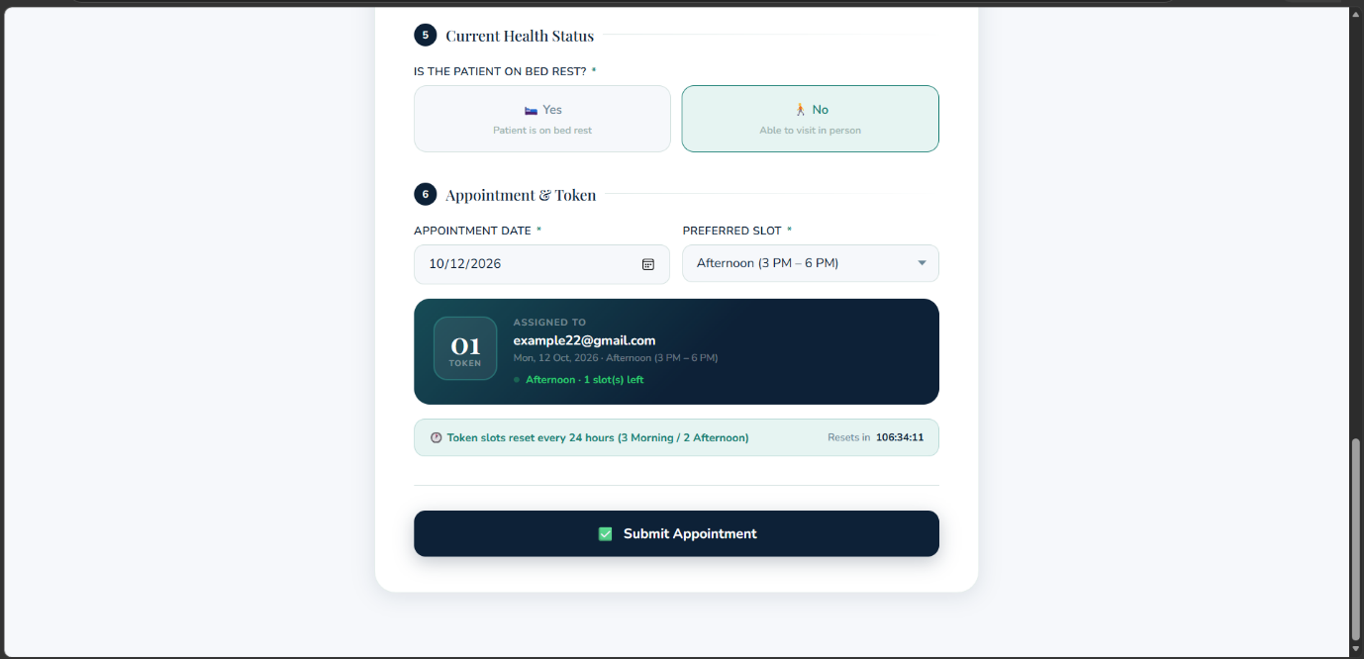
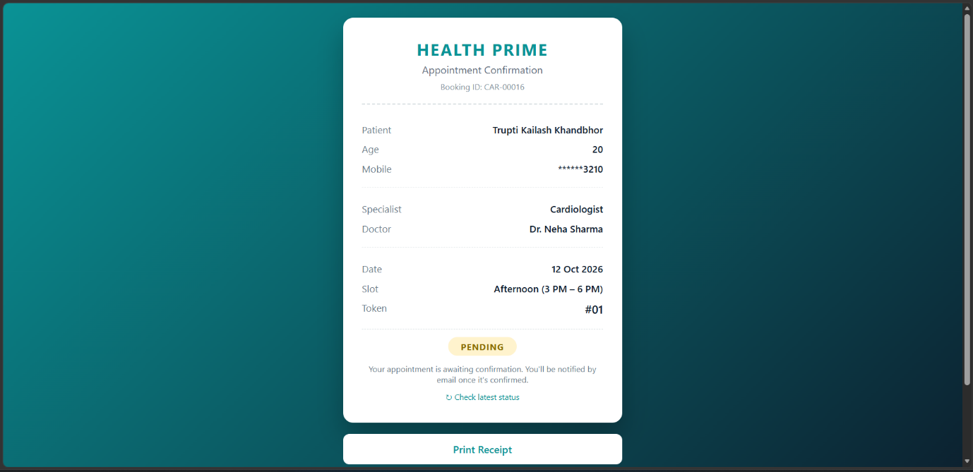
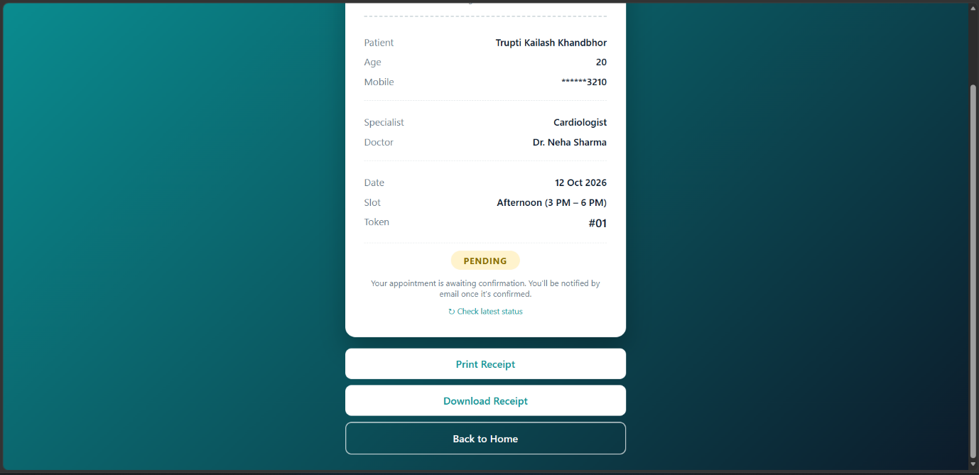
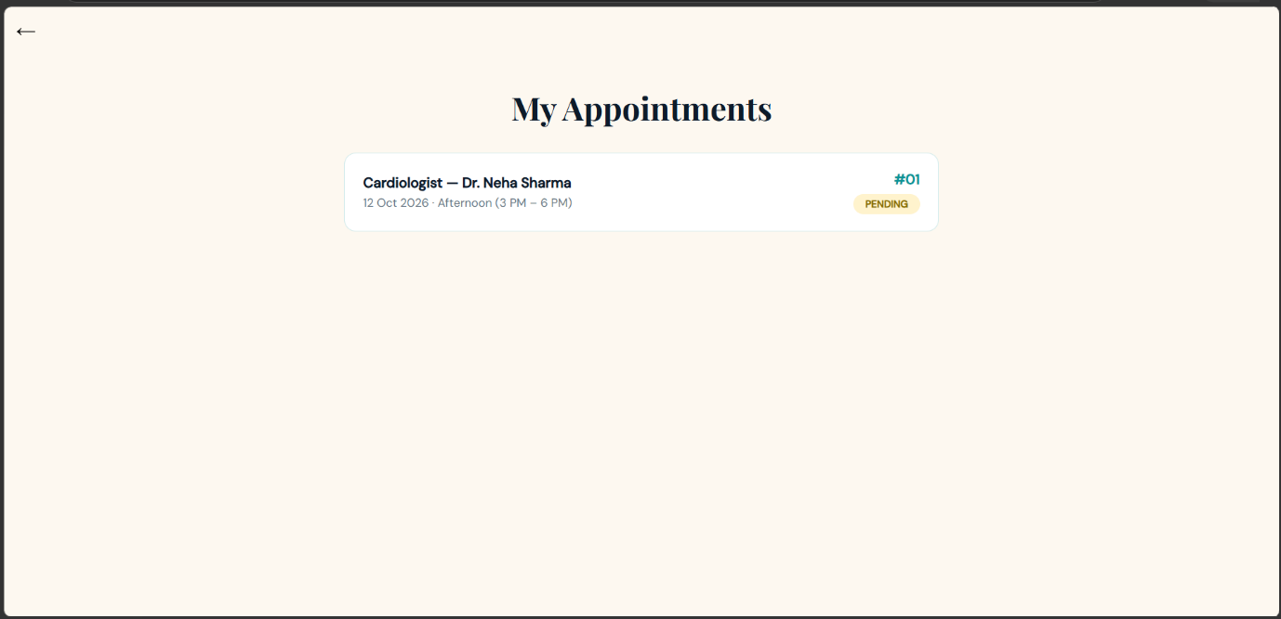
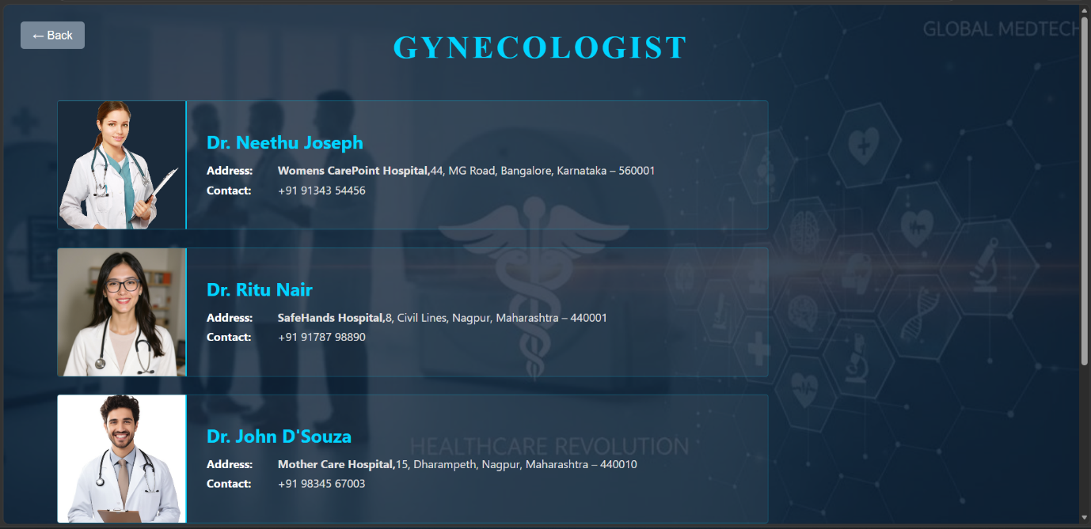
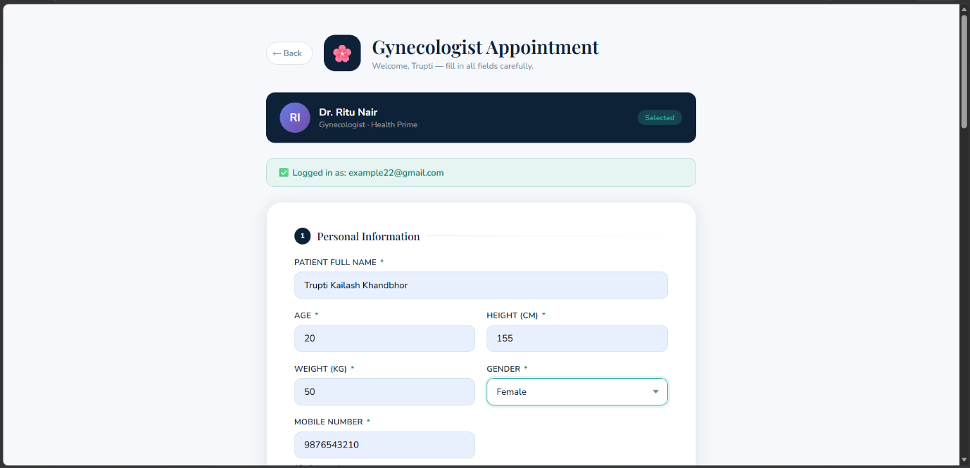
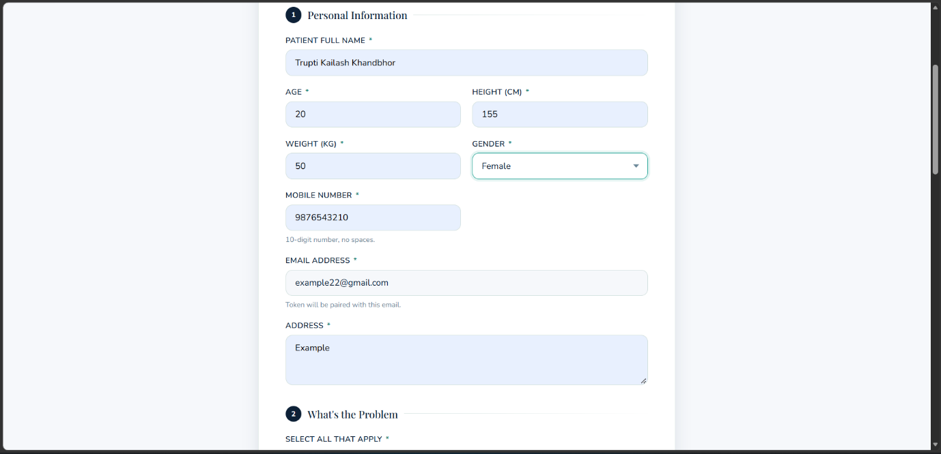
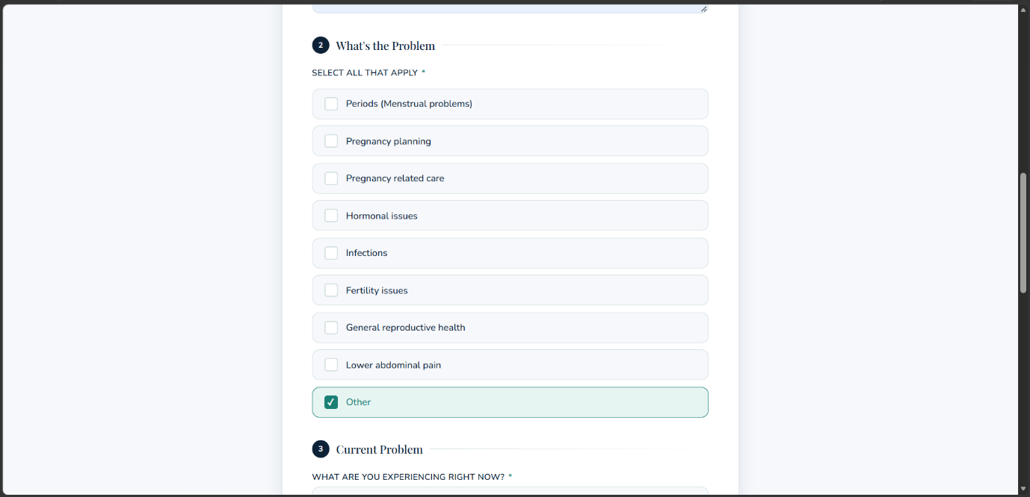
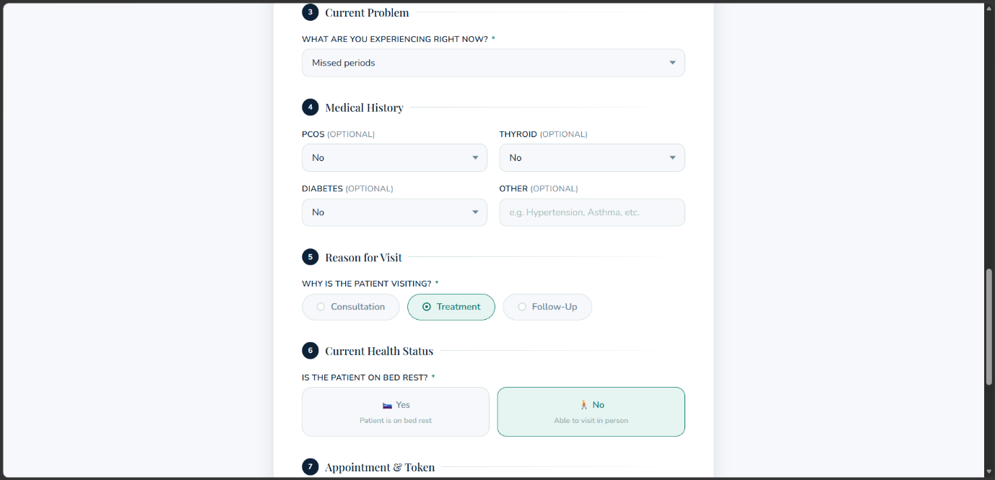
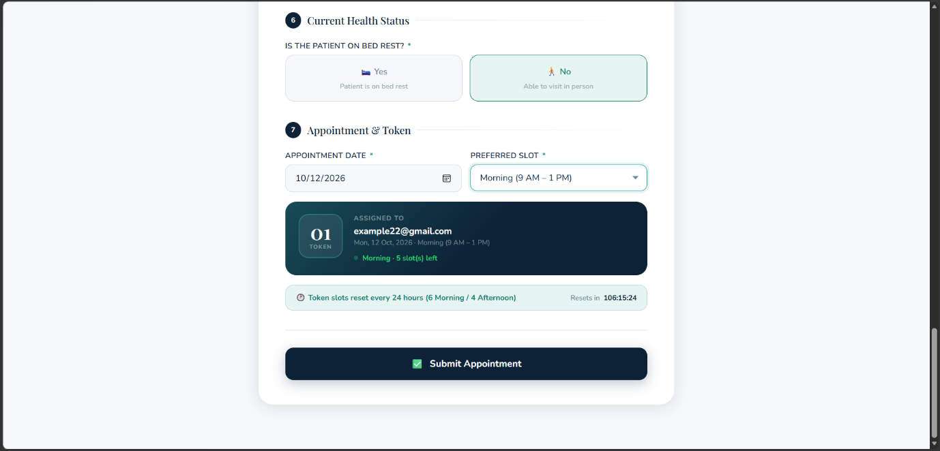
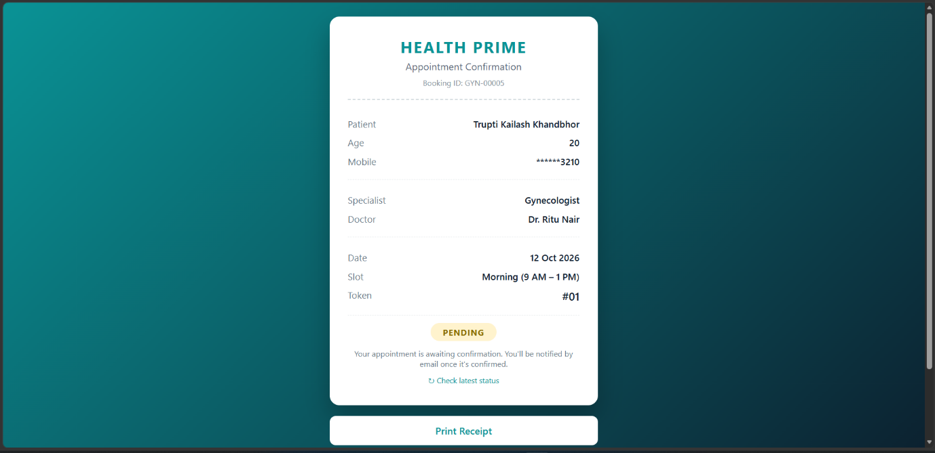
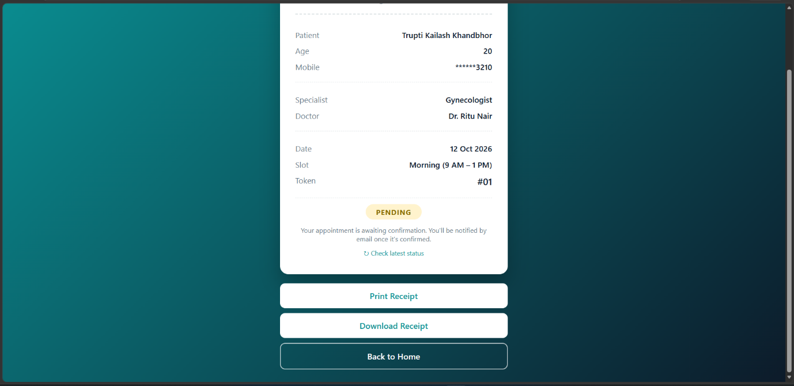
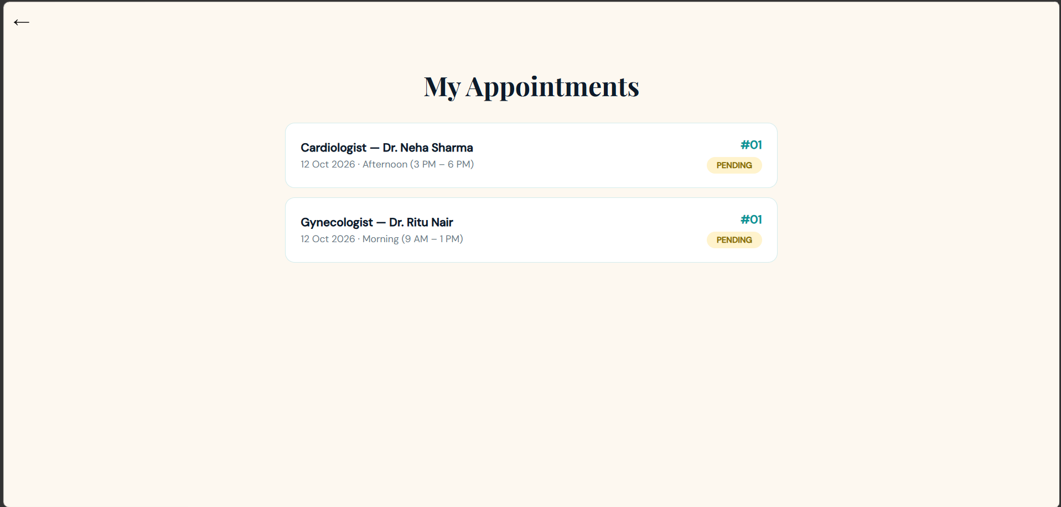
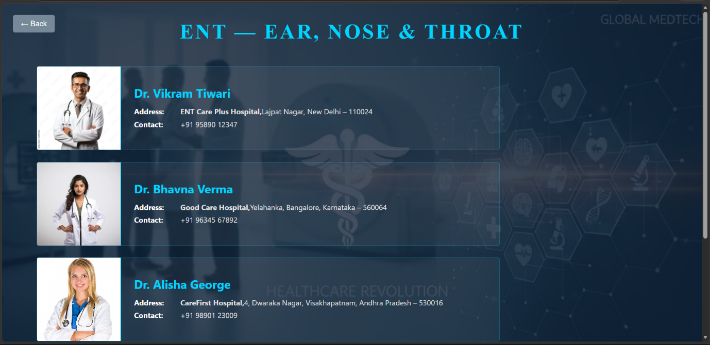
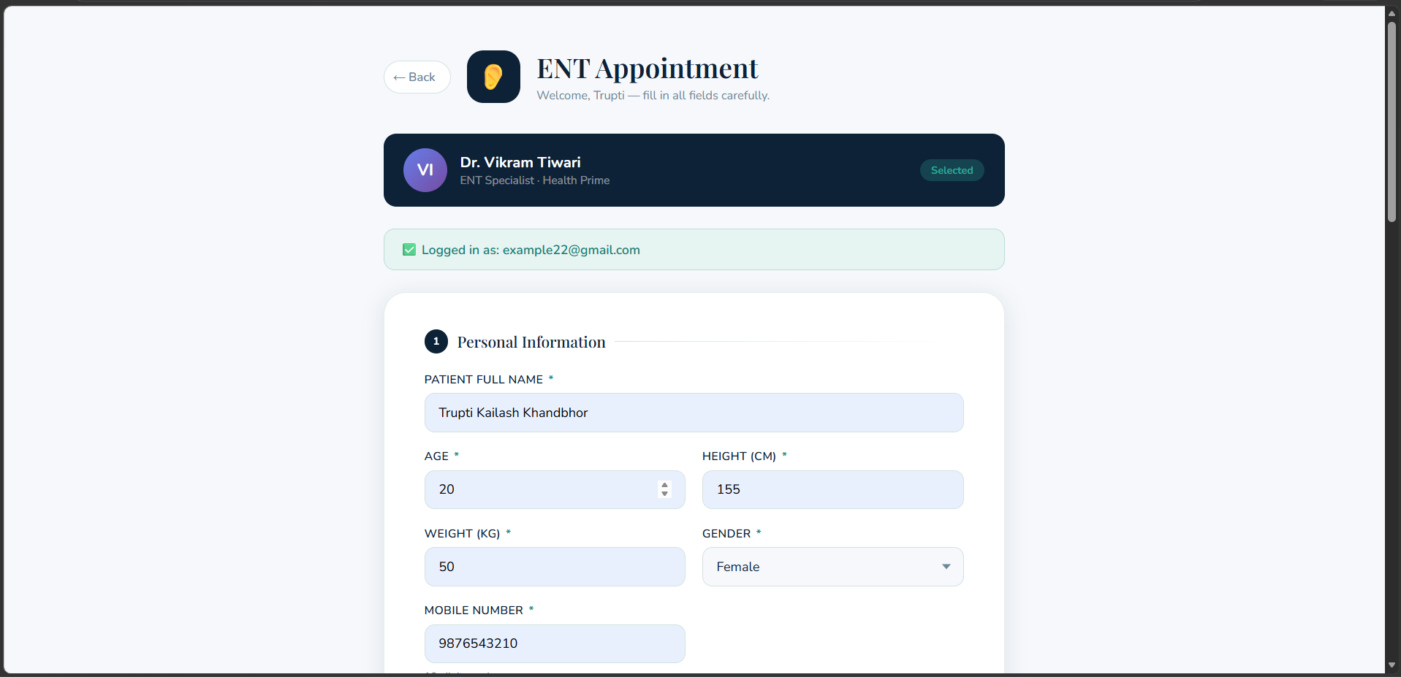
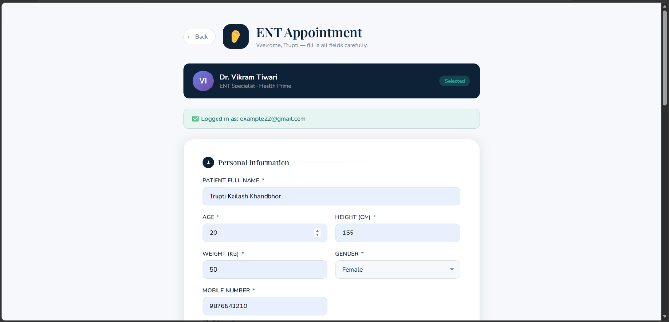
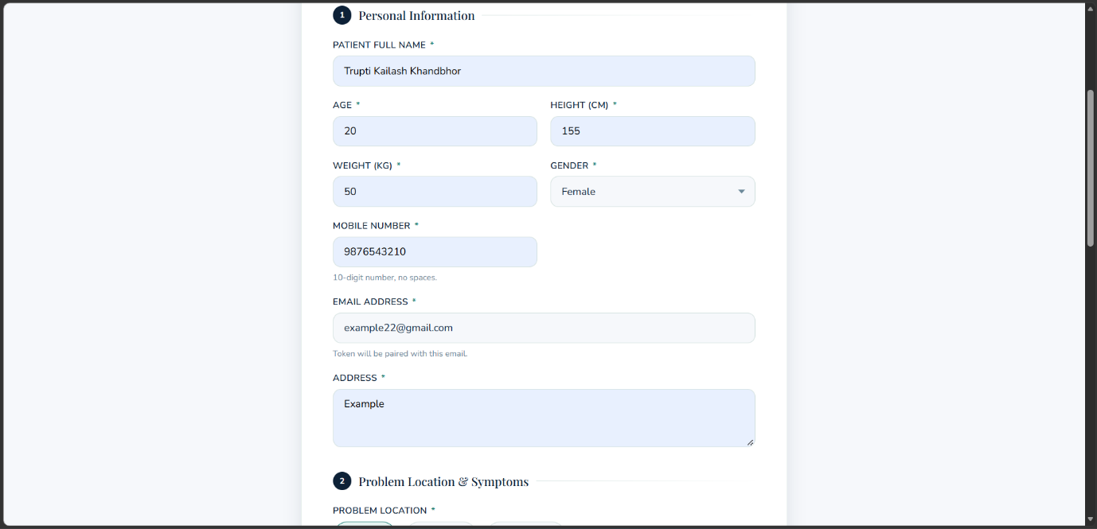
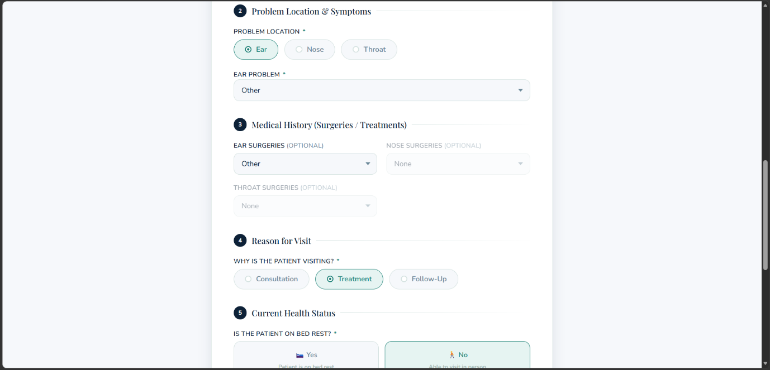
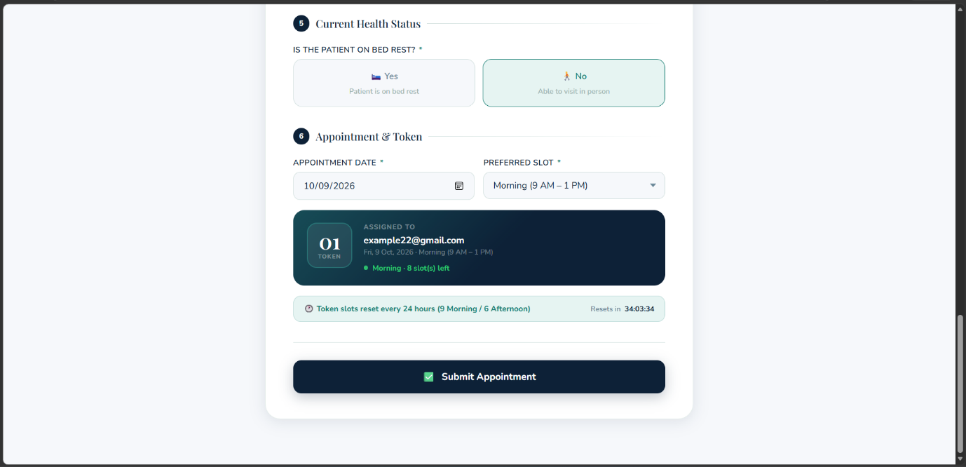
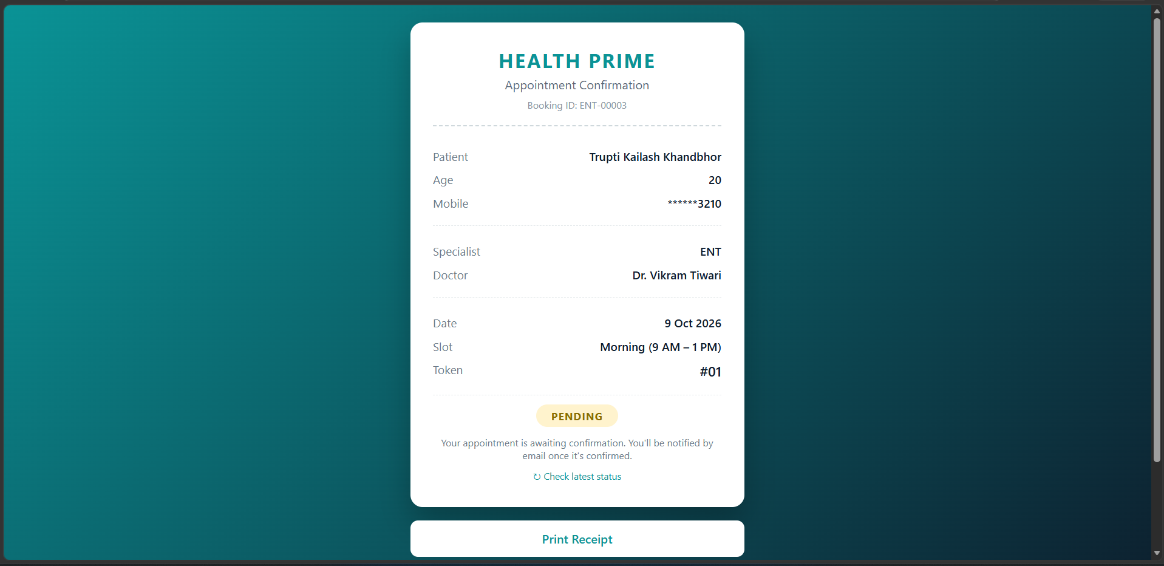
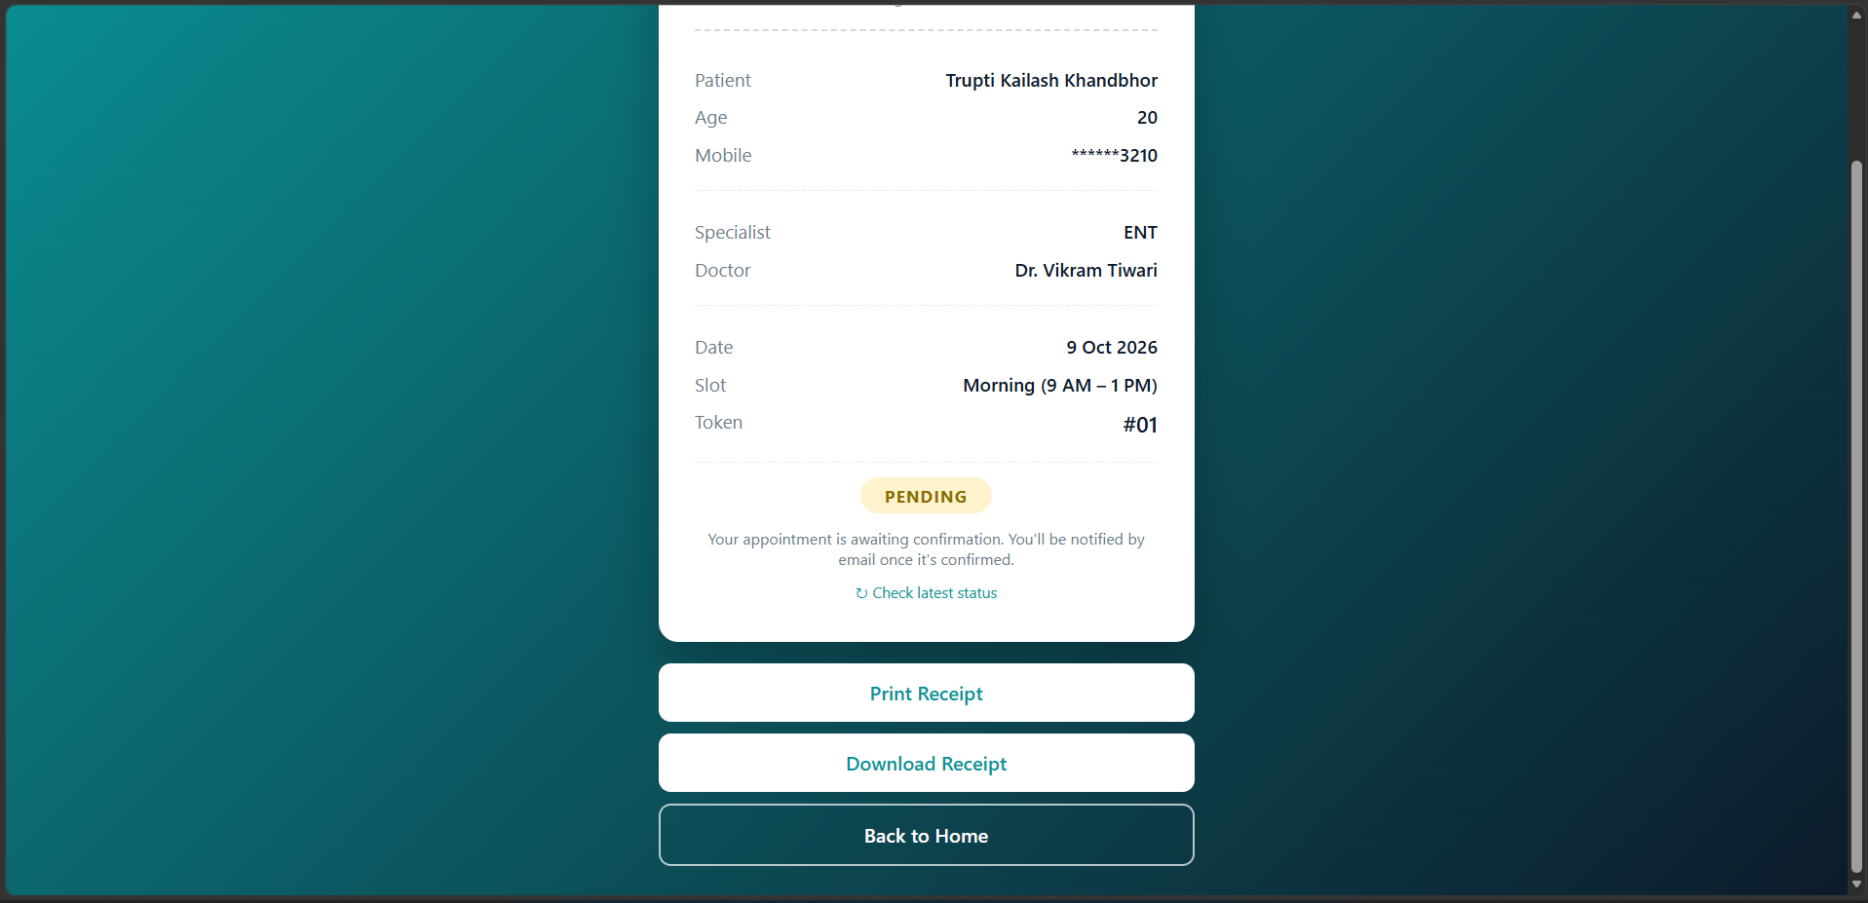
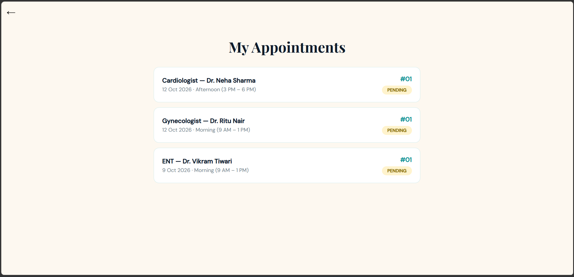
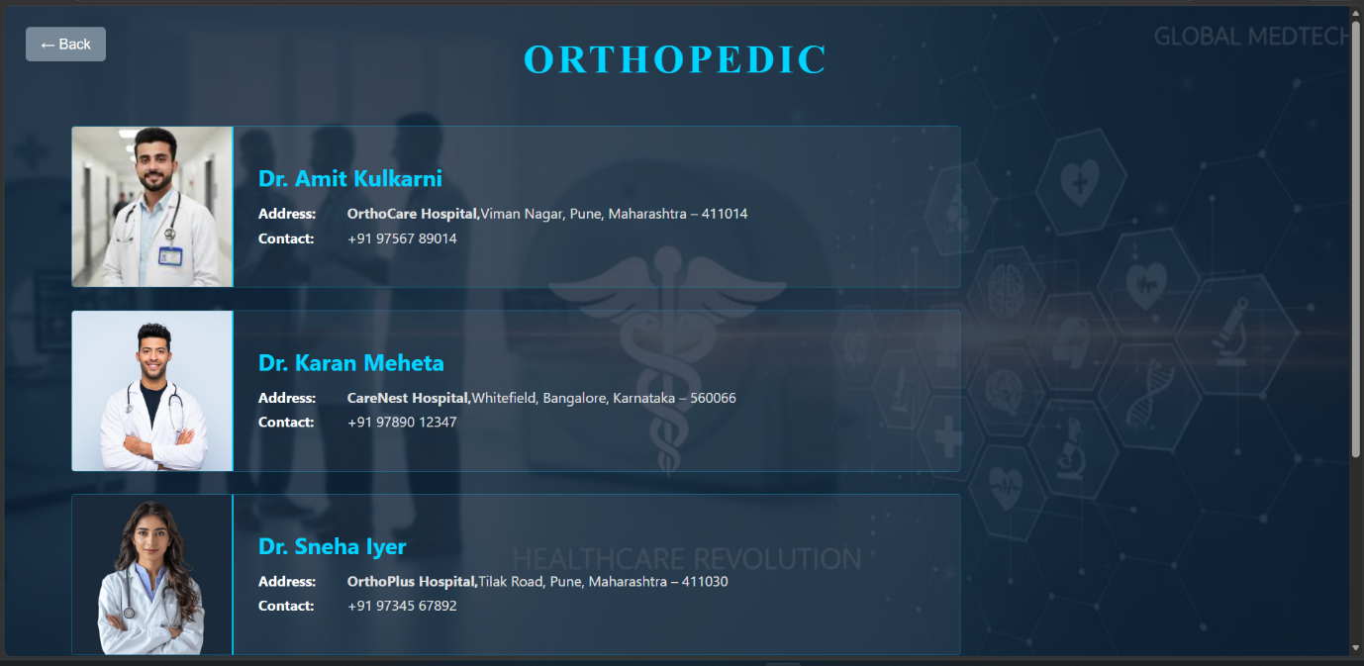
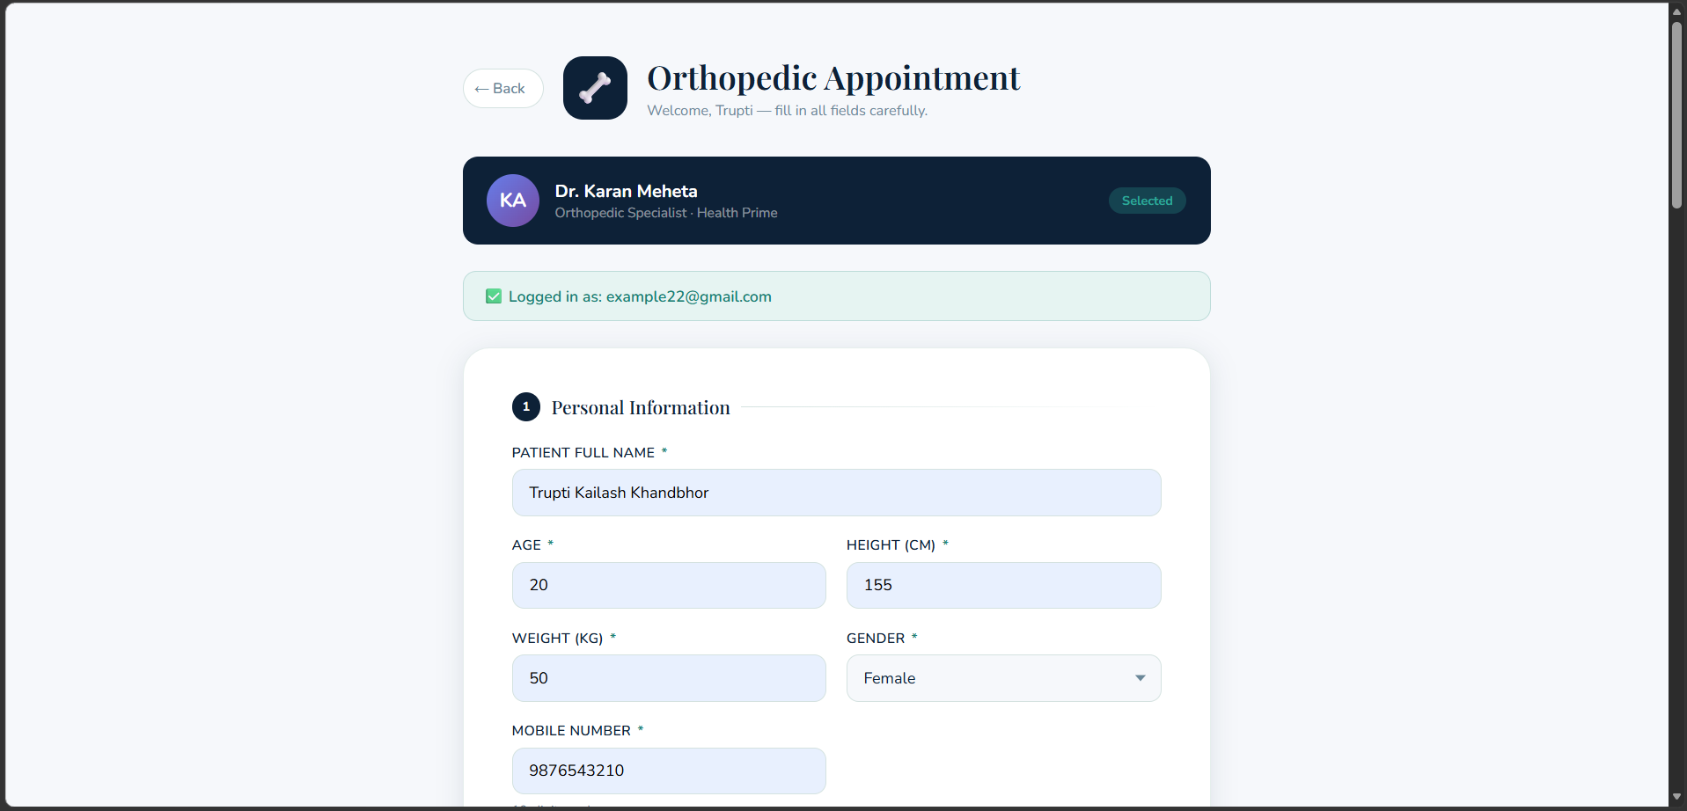
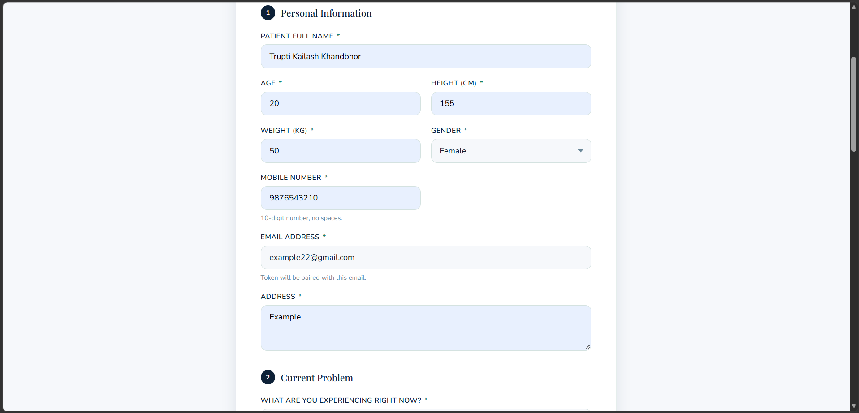
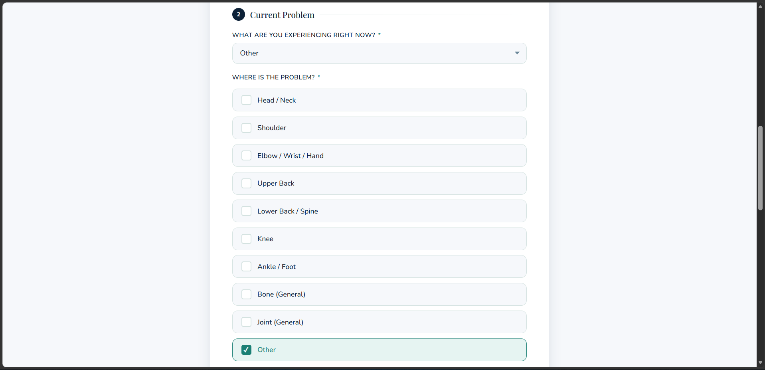
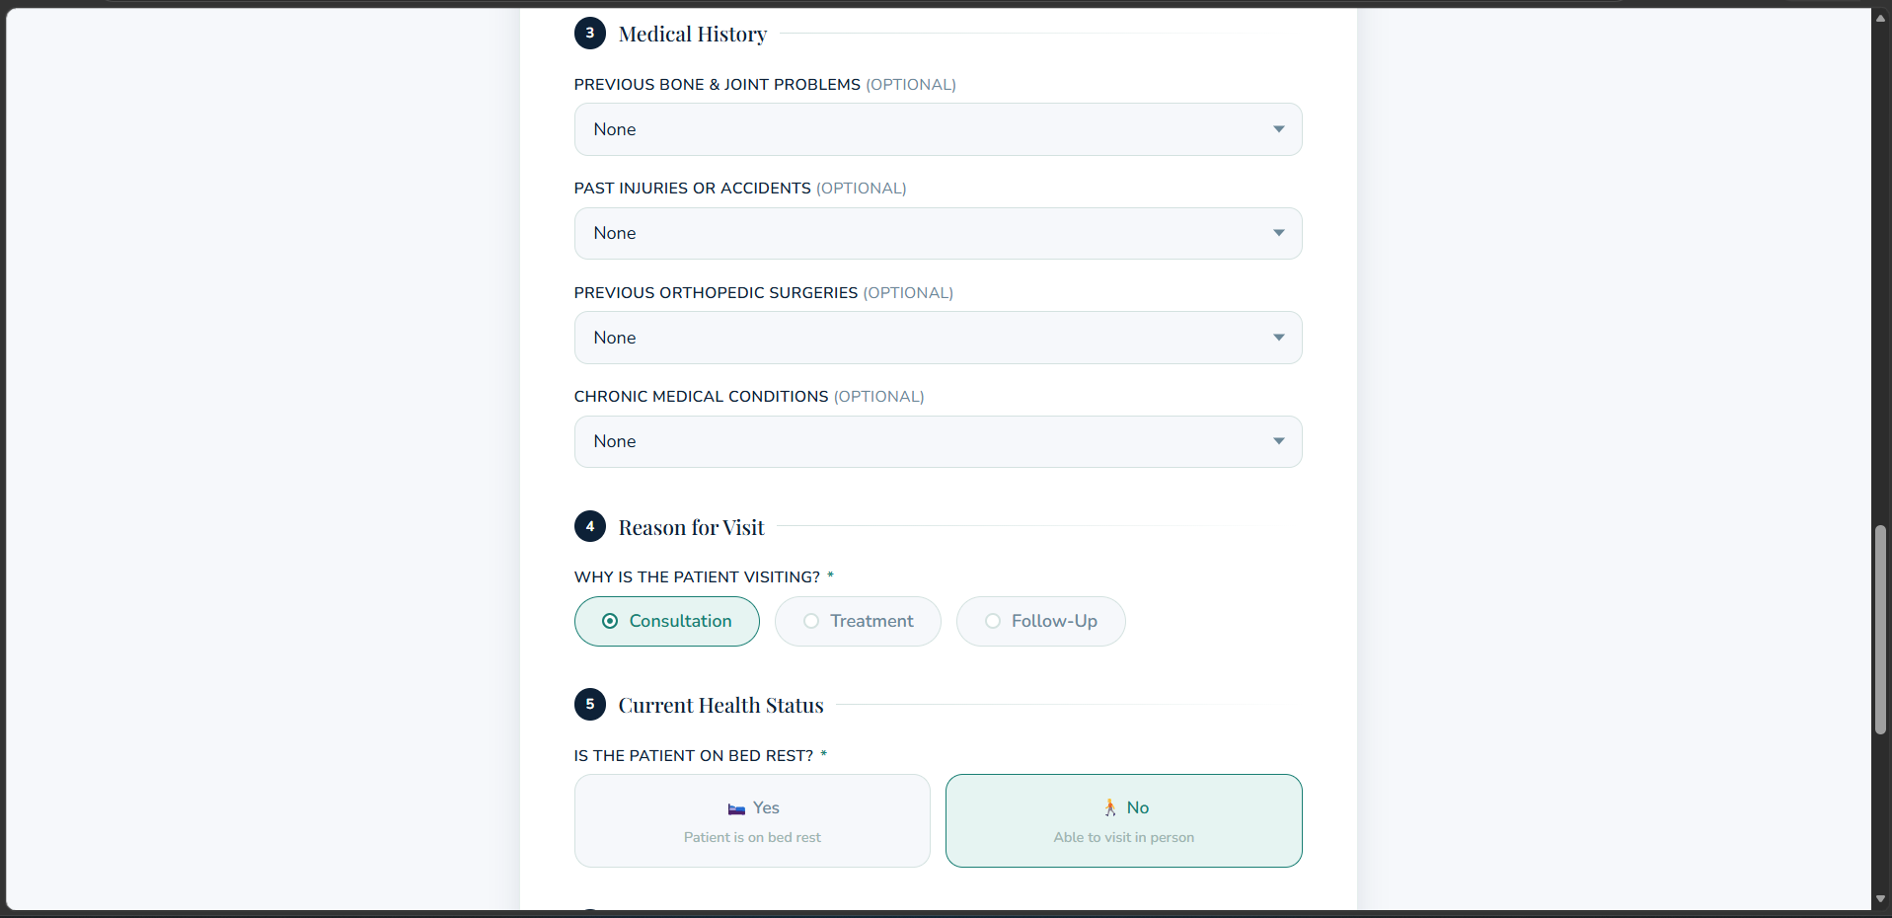
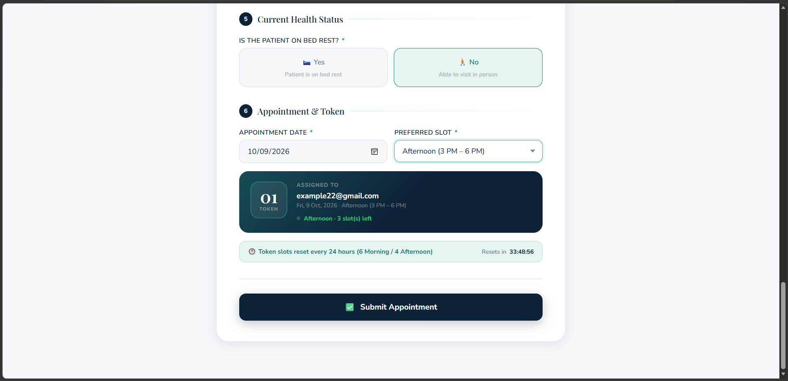
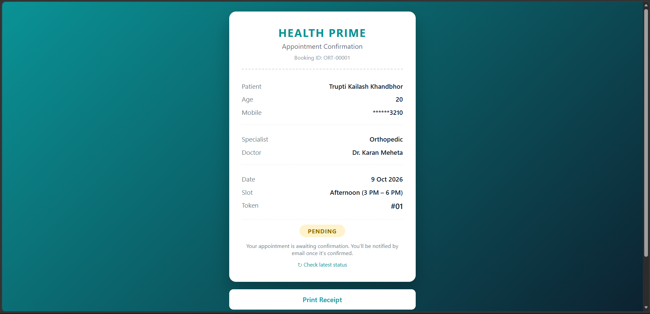
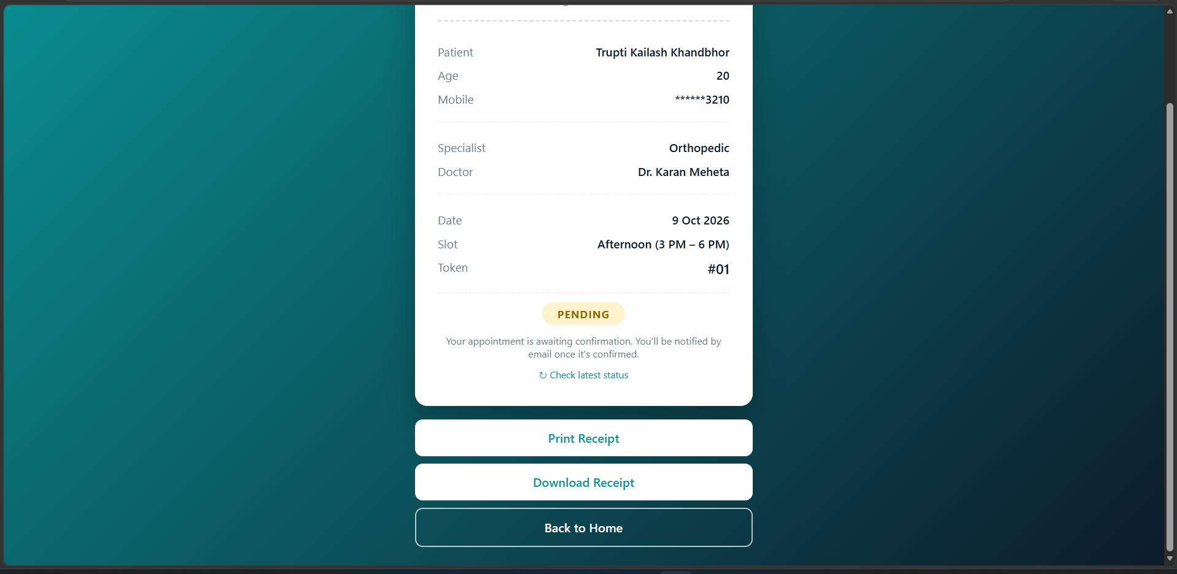
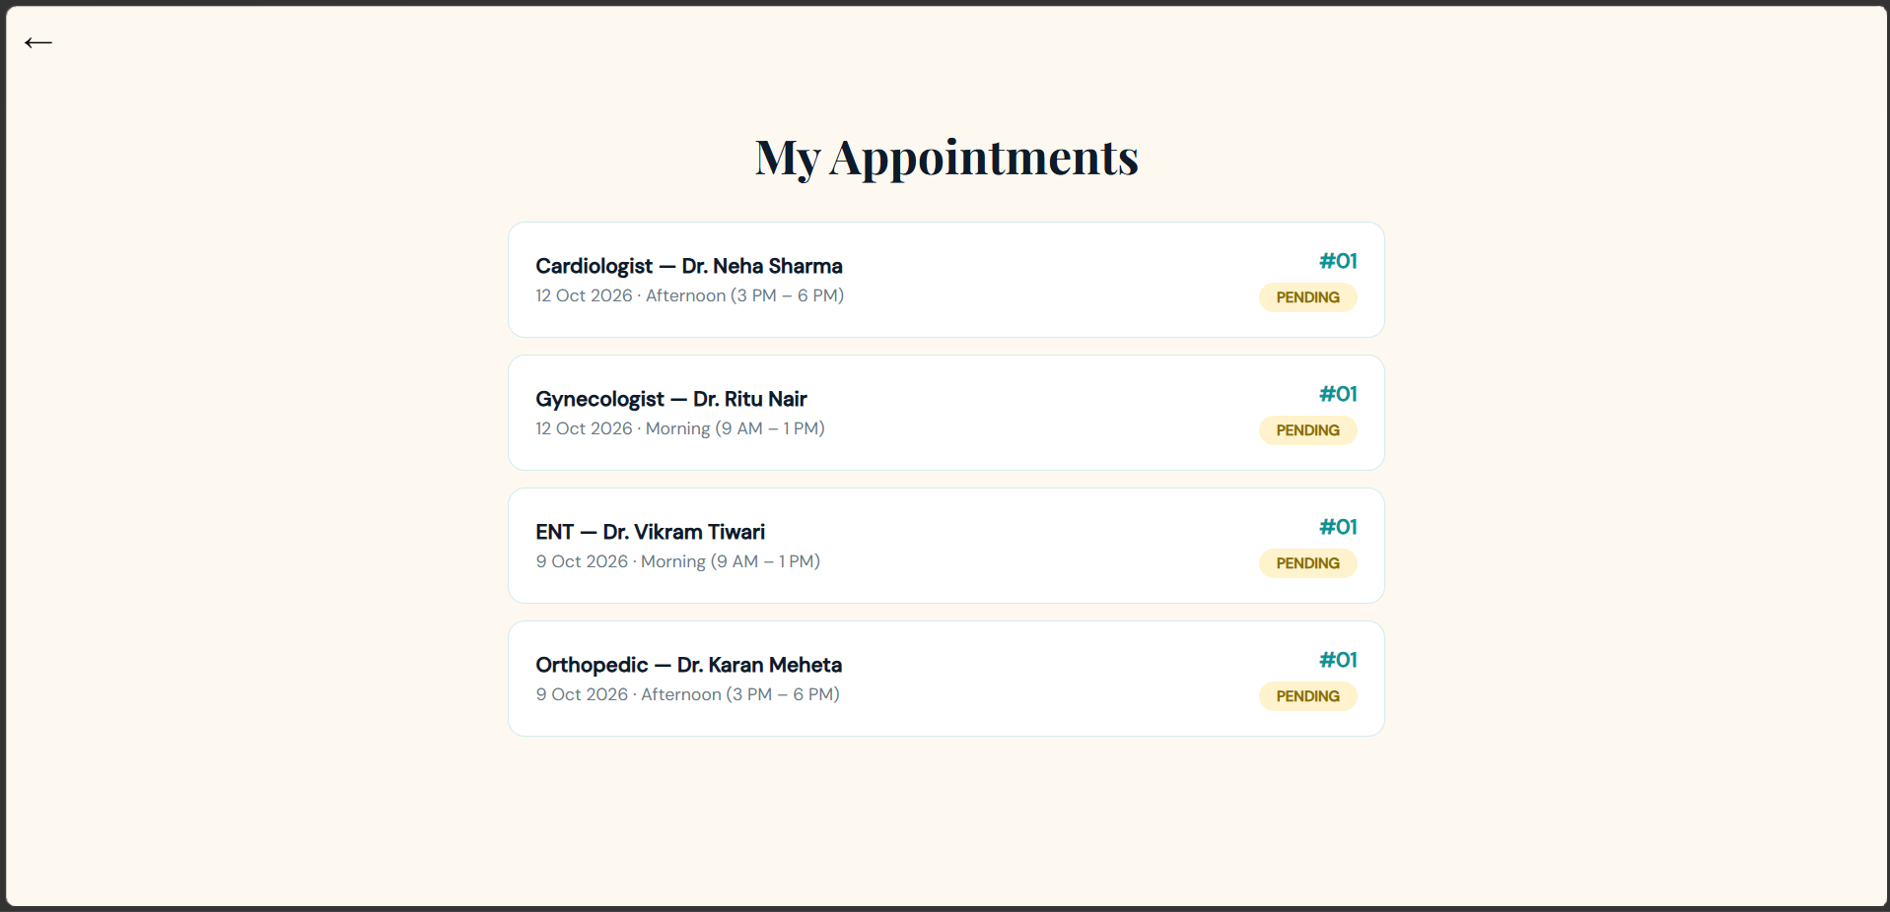
5.IMPLEMENTATION DETAILS

Implementation is the phase where the designed system is actually built, coded, and made functional. It involves translating the system design into working code, setting up the development environment, and integrating all components — frontend, backend, and database — into a complete, operational application.
Health Prime was implemented as a multi-page web application using a combination of client-side and server-side technologies. Each page was developed individually and linked together through a defined navigation and redirect flow. The implementation followed a structured approach — starting with the database schema, followed by the backend PHP logic, and then the frontend HTML/CSS/JavaScript interfaces.

5.1 Software Specifications
The following software tools and technologies were used in the development of Health Prime:
Component | Specification
Operating System | Windows 10/11 (development and testing environment)
Web Server | Apache 2.4 (bundled with XAMPP)
Database Server | MySQL/MariaDB (bundled with XAMPP)
Server-side Language | PHP 8.2
Client-side Technologies | HTML5, CSS3, JavaScript (vanilla — no frontend framework)
Email Library | PHPMailer v6.9.3 (added manually as local library files, since the environment has no Composer/package-manager access)
Database Administration | phpMyAdmin (bundled with XAMPP)
Local Development Stack | XAMPP (Apache + MySQL + PHP bundled installer)
Code Editor | Visual Studio Code
Browser Compatibility | Any modern browser — tested on Microsoft Edge and Google Chrome

5.2 Hardware Specifications
The following hardware configuration was used for the development and testing of Health Prime:
Component | Specification
Processor | Dual-core 2 GHz or higher
RAM | 4 GB minimum (8 GB recommended for running XAMPP, VS Code, and a browser simultaneously)
Storage | At least 1 GB free disk space (XAMPP installation + project files + database)
Display | Standard resolution (1366×768 or higher)
Network | Internet connection required only for sending email notifications (SMTP) — the core application runs fully offline on localhost otherwise

6. Outputs and Report Testing
Testing is a critical phase in the software development lifecycle. It ensures that the system functions correctly, meets the specified requirements, and handles both valid and invalid inputs gracefully. For Health Prime, testing was carried out to verify the correctness of all modules — including user registration, login, appointment booking, token generation, and contact form submission.
Two primary testing approaches were used: Black Box Testing, which focuses on testing the system's inputs and outputs without knowledge of the internal code, and White Box Testing, which examines the internal logic and flow of the code to ensure each path executes correctly.
6.1 Test Plan
Testing was carried out progressively as each module (patient booking, admin panel, doctor dashboard, request/approval workflow) was built, using a local XAMPP-equivalent environment (PHP built-in server with a MariaDB instance) to simulate the full request/response cycle for each role.
Scope of testing:
- Functional correctness of booking, login, and status-transition flows for all three roles.
- Data validation on all form inputs.
- Access control between roles (patient/doctor/admin) and between individual doctors.
- Security checks: SQL injection resistance, CSRF protection, XSS escaping, session isolation, and server-side enforcement of business rules (not just UI-level restrictions).
Testing types used: Black-box testing (validating inputs and outputs without reference to internal code) and white-box testing (verifying specific internal logic paths, such as permitted status transitions and database-level gating conditions).
Test environment: PHP 8.2, MariaDB 10.11, tested via both direct browser interaction and scripted HTTP requests simulating each role's session.

6.2 Black Box Testing and Data Validation Test Cases
Black box testing treats the system as a "black box" — the tester provides inputs and observes outputs without knowledge of the internal code. The focus is on whether the system behaves correctly from the user's perspective.
Test ID | Description | Input | Expected Output | Result
BB-01 | Patient login with incorrect password | Valid email, wrong password | Generic "Invalid email or password" message (does not reveal whether the email exists) | Pass
BB-02 | Patient login with correct credentials | Valid email and password | Redirect to intended page, session created | Pass
BB-03 | Doctor login with incorrect password | Valid username, wrong password | "Invalid username or password" message | Pass
BB-04 | Patient attempts to view another patient's receipt | Valid login, another patient's booking ID in URL | Access denied, redirected away | Pass
BB-05 | Logged-out user attempts to open receipt/dashboard URLs directly | Direct URL access, no session | Redirected to the relevant login page | Pass
BB-06 | Doctor reschedule request with a past date | Date earlier than today | Request rejected, no change saved | Pass
BB-07 | Admin creates a doctor account without selecting a valid name | Specialty selected, doctor name left blank | Form rejected with validation message | Pass
BB-08 | Contact form submitted with an HTML tag in the message | <b>test</b> in message field | Displayed as literal text in admin inbox, not rendered as HTML (XSS prevented) | Pass
BB-09 | Cancellation request submitted with no reason | Empty reason field | Request rejected, no database change | Pass
BB-10 | Admin denies a doctor's request without a reason | Empty denial reason | Request rejected, appointment unchanged | Pass

6.3 White Box Testing — Functional Validation Test Cases and Results
Test ID | Description | Code Path Verified | Expected Behavior | Result
WB-01 | Appointment status transition logic | doctor_update_status() | A Pending appointment can only move to Confirmed or Cancelled; a direct attempt to set it to Completed is rejected | Pass
WB-02 | Status transition after Confirmed | doctor_update_status() | A Confirmed appointment can only move to Completed or No-show, never directly back to Cancelled | Pass
WB-03 | Cross-doctor data isolation | doctor/appointment.php query (WHERE doctor_name = ?) | A doctor requesting another doctor's patient record by ID receives a 404, not the record | Pass
WB-04 | Admin cannot act on a Confirmed appointment without a pending request | admin_cancel_confirmed(), admin_reschedule_confirmed() | A forged cancel/reschedule request with no matching doctor_request flag updates zero rows | Pass
WB-05 | Reschedule date cannot be set by admin | admin_reschedule_confirmed() | Function accepts no date/slot parameters at all — a forged POST containing a different date is silently ignored; the doctor's originally requested date is applied | Pass
WB-06 | CSRF protection on state-changing requests | csrf_check() | A POST request without a valid CSRF token is rejected with HTTP 400 | Pass
WB-07 | SQL injection resistance | All database write functions | All queries use parameterized prepared statements (mysqli_stmt_bind_param); no raw string concatenation of user input into SQL | Pass
WB-08 | bind_param type-string correctness | CardiologistSubmit.php | A previously mismatched type string caused bypass_surgery to always save as 0; corrected and re-verified to store "Yes"/"No" correctly | Pass
WB-09 | Session isolation between roles | session_name() per role | Logging in as a patient, doctor, or admin does not grant access to the other two roles' protected pages, since each uses a separate session cookie | Pass
WB-10 | Graceful handling of email delivery failure | send_status_email() | When SMTP credentials are invalid/unreachable, the appointment status update still completes successfully; the email failure is logged, not fatal | Pass

7. Conclusion and Recommendation
7.1 Conclusion
Health Prime successfully demonstrates a complete, role-based hospital appointment booking system that replaces the inefficiencies of manual scheduling with a structured, accountable digital workflow. Over the course of development, the system evolved from a basic booking form into a three-tier platform where patients, doctors, and administrators each operate within clearly defined boundaries — most notably through the request-and-approval workflow, which ensures that no confirmed appointment can be cancelled or rescheduled without a documented reason that is visible to the patient.
The project met its core objectives: patients can independently track their appointment status in real time without contacting the clinic; doctors can manage their own patient queue without needing administrative intervention for routine actions; and administrators retain full oversight without being able to unilaterally override a doctor's medical scheduling decisions. Along the way, the project also involved identifying and correcting real security and logic issues in the original codebase — including a data-binding bug that silently corrupted a medical field, an open-redirect vulnerability, and unescaped output vulnerable to XSS — reinforcing secure coding practices such as prepared statements, CSRF protection, password hashing, and server-side enforcement of business rules rather than relying on hiding buttons in the interface.
Beyond the functional outcome, this project provided practical experience in full-stack web development: structuring a relational database across multiple related tables, managing three independent authentication systems within a single application, integrating a third-party library (PHPMailer) without a package manager, and iteratively testing each feature against real user scenarios before considering it complete.

7.2 Recommendations and Future Scope
While the system is fully functional for its intended scope, several enhancements would strengthen it further if development continued:
- Server-side token validation — Token numbers are currently generated on the client side at the time of booking. A future version should validate and assign tokens on the server, within a database transaction, to eliminate any possibility of two patients receiving the same token for the same doctor, date, and slot.
- Dynamic doctor listing pages — The four specialty pages (Cardiologist, Gynecologist, ENT, Orthopedic) are currently static HTML with doctor details hardcoded in. Converting these to PHP pages that read from the doctors table would allow the existing availability toggle to actually prevent new bookings for an unavailable doctor, and would let admin add or remove doctors without editing HTML files directly.
- Online payment integration — Adding a payment gateway (e.g., Razorpay or Stripe) for consultation fees would move the system closer to a production-ready clinic tool.
- SMS notifications — In addition to email, integrating an SMS gateway (such as Twilio or MSG91) would improve reach for patients who may not check email regularly.
- Mobile responsiveness audit — While the interface uses relative layouts in most places, a dedicated responsive-design pass (particularly for the admin and doctor dashboards) would improve usability on smaller screens.
- Automated testing suite — Testing during development was performed manually and through scripted HTTP requests. Introducing a formal automated test suite (e.g., PHPUnit) would make regression testing faster and more reliable as the system grows.
- Production deployment — The system has been built and tested on a local XAMPP environment. Deploying it to a live server with a proper domain, SSL certificate, and production-grade database credentials would be a necessary next step for real-world use.
- Multi-hospital support — The current design assumes a single clinic. Extending the schema to support multiple hospital branches, each with its own doctors and admin accounts, would broaden the system's applicability.

8.FUTURE SCOPE

- Telemedicine integration — Adding video consultation support would allow doctors to conduct remote appointments directly through the platform, particularly useful for follow-up visits that don't require a physical examination.
- E-prescriptions — Once a doctor marks an appointment as Completed, they could issue a digital prescription linked to that visit, which the patient could then view or download alongside their receipt.
- Patient medical history across visits — Currently, each booking is a standalone form. A future version could maintain a running medical history per patient, so a doctor can see a patient's past visits, conditions, and outcomes when a new appointment is booked with the same or a different doctor.
- AI-assisted symptom pre-screening — Before a patient selects a specialty, a simple guided questionnaire could suggest the most relevant specialist based on their symptoms, reducing misrouted bookings.
- Insurance and billing integration — Linking appointments to insurance verification and generating itemized bills would move the system closer to what a real hospital's administrative workflow requires.
- Native mobile application — Building dedicated Android/iOS apps (or a Progressive Web App) would let patients book and track appointments more conveniently than through a mobile browser, with push notifications replacing/supplementing email alerts.
- Multi-language support — Given the system's likely user base, adding regional language support (e.g., Hindi, Marathi) alongside English would make the platform more accessible to a wider range of patients.
- Analytics dashboard for admin — Beyond the current counts, a future admin dashboard could show trends over time — busiest specialties, peak booking hours, no-show rates per doctor — to support data-driven staffing and scheduling decisions.
- Multi-branch/multi-hospital support — Extending the system to manage several hospital branches under one platform, each with its own doctors, admins, and patient records, would make it viable for a hospital chain rather than a single clinic.
- Patient feedback and doctor ratings — After a Completed appointment, patients could be prompted to rate their experience, giving the hospital measurable feedback on service quality per doctor.
- Integration with wearable health data — For specialties like Cardiology, allowing patients to optionally share data from fitness trackers or health monitoring devices ahead of their appointment could give doctors more context before the consultation.

9. BIBLIOGRAPHY AND REFER11ENCES

The following resources were referred to during the planning, development, and documentation of the Health Prime Doctor Appointment Booking System.
Technical References
- PHP Documentation
PHP: Hypertext Preprocessor – Official Documentation
https://www.php.net/docs.php
- MySQL Documentation
MySQL – Official Documentation
https://dev.mysql.com/doc/
- MDN Web Docs
HTML, CSS, and JavaScript Web Development Documentation
https://developer.mozilla.org/
- W3Schools
References and tutorials for HTML, CSS, JavaScript, PHP, and MySQL
https://www.w3schools.com/
- GeeksforGeeks
Programming, Web Development, PHP, and Database concepts
https://www.geeksforgeeks.org/

Project-Specific References
- Dr. Gujar's Clinic
Guidance and domain-related suggestions regarding patient information, specialist-specific forms, and the appointment booking process.
- Riddhi (Friend) – Medical Student
Feedback and suggestions regarding the specialist-specific forms, patient information, and improvements to the website.
Development Tools
- XAMPP
Local development environment used for PHP and MySQL development.
https://www.apachefriends.org/
- Visual Studio Code
Source-code editor used during website development.
https://code.visualstudio.com/

